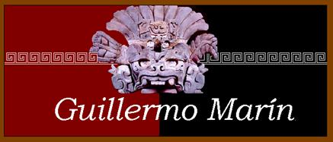
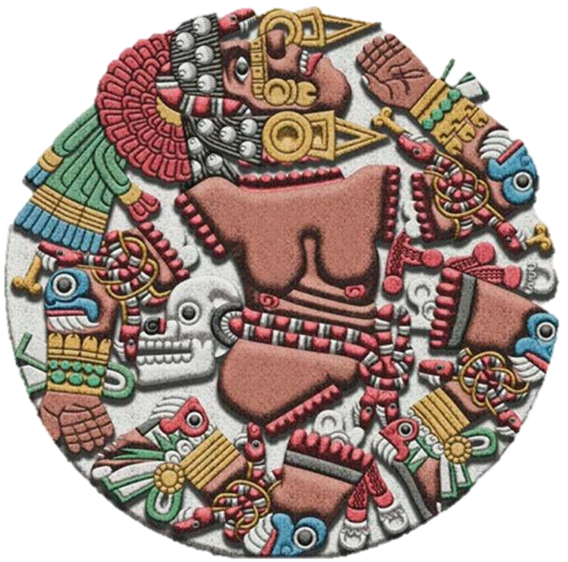
Where are the MEXICA
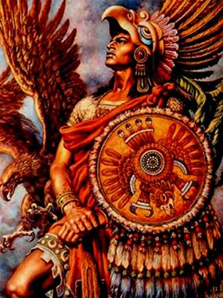
I
t's interesting, that within the 62 indigenous peoples and 85 languages that INEGI recognizes in this country, the mexicas, wrongly called Aztecs, do not appear listed. Official figures claim that approximately 10% of "Mexicans" are indigenous, because they recognize to speak a native language. The question is: how many of the respondents speak another language and deny it out of embarrassment, and how many more, that do not speak a native language, culturally live under ancestral habits and customs? Mysteries of identity.
It is significant that native peoples do not self-recognize themselves as "Mexicans". They are, as the case may be: Nahua, Maya, Zapotec, Mixtec, Yaquis, Pames, etc. Mexican comes from "Mexica", so that peoples who have identity, language and culture, do not recognize themselves as "Mexicans". So, who are then the Mexicans and where are the famous Mexica? Would then "Mexicans" be those who do not have any sense of identity and, could it be, that the real Mexica are hidden and crouching in the "center of the heart" of the colonizer monster.
Those who invented "Mexico and Mexicans", were creoles in the early 19th century, while betraying their relatives the gachupines and started a civil war, using indigenous peoples as cannon-fodder, which later, in its "official history", have called with euphemism, "War of Independence". But a creole ideology against the gachupines started since the 18th century, who had excluded them from high level positions in Government, Church and the army. The caste system was maliciously created by the Spanish Crown to permanently confront its subjects in the Viceroyalties and keep them from forming alliances against it.
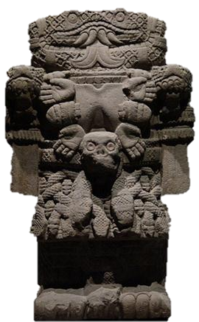
The Creole ideology is based on that "they" are the true natives in these lands and not the gachupines. The original peoples, in this "ideological-political-economic" case, were never taken into consideration (still are not). It was a struggle between gachupines in power and creoles fighting for access to it. The "father" of the Creole ideology was Francisco Javier Clavijero. Concepts such as "creole maize" or "creole nut", is a good example to understand that the "own-original" of these lands, for the creoles was, creole! Not the indigenous or anahuaca. The gachupin was from "castile", the original here, was "the creole". And to this day they still unconsciously use these misconceptions, colonizing and intended to exclude.
For those of "castile", their "ancestral" origins placed them in "the Greco-Roman" culture; the creoles on the other hand, invented a "great ancient and ancestral culture, the most powerful and dominating in all the Anahuac", not more nor less than... the Mexica! Those who their ancestors, conquerors and early settlers allegedly defeated as one of "great civilizing achievements of the West" Not more nor less. That is the ideological origin of the "Aztecs".
Thus, the "Aztecs" appeared as the most important culture of "Pre-Hispanic Mexico", grotesque creole concept in the history of the Anahuac, because the "prehispanic" name devalues and loses its essence, the anahuaca, only is and exists as of the arrival of the invaders. The creoles began to recreate a mythical Mexico-Tenochtitlan, in texts and illustrations of that era, depicted the "Aztecs" as "the prehispanic-greeks", with metal helmets, capes, spears and shields very similar to the illustrations of the classical Greece. The creoles needed to glorify their "supposed ancient past", against the gachupines.
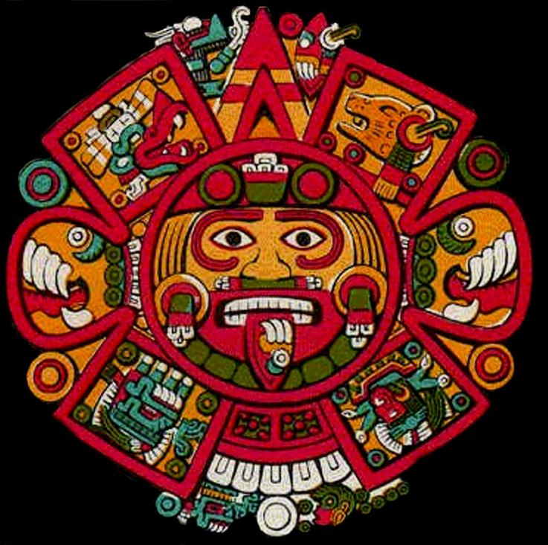
The "creole official history", which began with Porfirio Díaz and his book of State, "Mexico through the centuries" (1884), describes among myths and fantasies a "pre-Hispanic Mexico" basically in the Mexica. And from there to the current textbooks. The Maya, Zapotec, Mixtec, Purépecha and other peoples only remained as scenic decoration, and only for investigation of foreign experts. It can clearly be seen in the museum-graphic script of the National Museum of anthropology and history, where on the ground floor are the "dead indians " that have given glory to the creole State and money from tourism. Occupying the most important and central location the Mexica room. And on the second floor, "Indians reluctant to progress", opposed to the "economic development projects" in their lands. By the way, on the second floor "modern Indians", have no face, noted Dr. Guillermo Bonfil Batalla, in his day.
The de-colonized history of the Cem Anahuac recognizes peoples far more numerous and more powerful warriors than the Aztecs in 1519. We can refer to the Maya or the Purepecha Peoples. Then, what is the reason that the mexicas appear on "sources" as the most important people. Simply because they were conquered first by the invaders and "studied", as Sahagún wrote, "to better destroy them". Indeed, the invasion of the Cem Anáhuac began in the Central Highlands with the Nahua peoples. Why there and not,—for example—in the Yucatan peninsula, which was closer and accessible place geographically for the Spaniards? Because of the internal Mexica problems which were suffering and the opposition of their tributary peoples, it turned them into a weak condition.
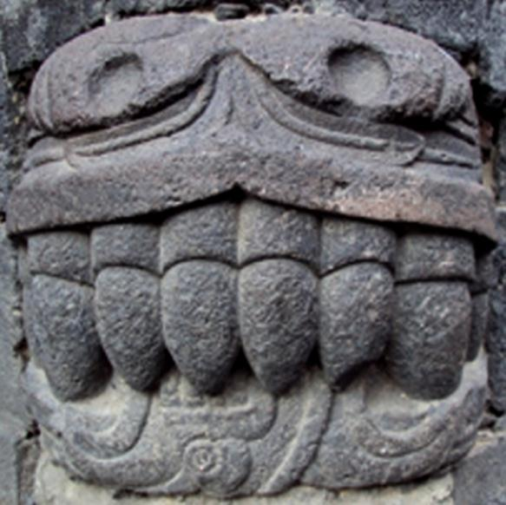
Tlacaelel, the longevous mexica Cihuacoatl, was the transgressor of the ancient philosophy known as Toltecáyotl. In the very bosom of the establishment of the Triple Alliance a crisis was experienced due to these transgressions, as well as the arbitrariness of Moctezuma with Texcoco and excesses with tributary peoples. Cortes, with the help of traitor "Malinche", who made him aware of the philosophical-religious crisis that the Mexica were experiencing and political problems with the tributary peoples, went to the heart of the Triple Alliance and provoked a civil war between the own Nahua peoples of the highlands. And then, with the Mexica themselves and their allies invaded the Cem Anáhuac. The great war effort of the first decades of the invasion involved basically the mexicas, texcocanos and Tlaxcala, the Spanish "conquest" is another myth of the creole ideology. Cities founded by the Spaniards as Puebla, Oaxaca, Morelia, Zacatecas, San Luis Potosí, etc., was supported by thousands of Nahua warriors, their families and a handful of Spaniards.
Then, where are the Aztecs in our times? We might suppose that there are three kinds of "Mexica": the historical ones, those of the Academy, and the ideological.
The historical Mexica arguably are the current inhabitants of the downtown Mexico City. Indeed, the "Barrio Bravo de Tepito", is the stronghold of the mexicas. At least there are two versions of the origin of the name "Tepito". According to Cecilio. A. Romero comes from Teocultepiton and according to the "Mexican Spanish language vocabulary" comes from "Tepiyotl". In both cases, it refers to a quarter of the ancient city of Tenochtitlan, which is what "survived" the Spanish occupation, resisted and succeeded in remaining to this day. Indeed, Tepito is a landmark of the city and of the "Mexican". Although, they have lost the nahuatl language, have their own language and maintain the nahuatl singsong and cadence. They have their own "divinity"; it was Huitzilopochtli before and today is "The Holy Death" (La Santa Muerte). They are still effective merchants and brave warriors. Until today, Tepito is a "liberated territory" from the neo-colonial creole Government, important commercial center as it was Tlatelolco in the past and emblem of cultural resistance for the whole country.
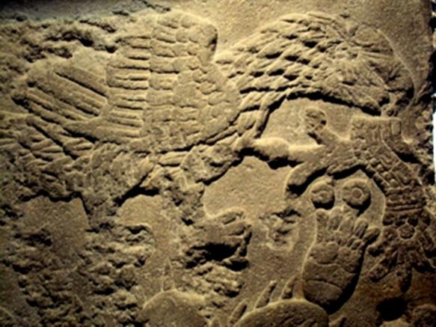
The academic "Mexica", are a fiction created from so-called "sources" written in the 16th century, beginning with "the first historian of pre-hispanic Mexico", none other than the very Hernán Cortes with his "letters of relation" (legalist allegation, full of lies and misrepresentations, which sought to justify the betrayal to the Spanish Crown Governor of Cuba Diego Velázquez), which today are taken as reliable factual historical evidence. Including of course what was written by Francisco Javier Clavijero with his "ancient history of Mexico" written in 1780 (note that the name of Mexico already appears instead of Anahuac). Up to the "encased" and "maiceados" historians of the creole neo-colonial system of our days, that without any shame and critical sense, continue repeating spanish lies about a civilization that to date, they have not been able to, or wanted, to understand and know. "Television brain" researchers that market the "Aztec" rattle and burn copal in official theatrical neocolonial "ceremonies of the ancient origins of the pre-hispanic history" of the creole country and for the creoles.
And finally, "the ideological Mexica", which in general are culturally mestizo, urban and new. People who are looking for an alternative to the brutal failure of "modernity" and the ravages of savage capitalism, which is destroying popular and ancestral cultures, nature and the environment, condemning people to poverty and desolation, particularly in areas of community and spiritual values. People who generally lack accurate de-colonized information and do not perceive the schemes and cultural neutralization suffered, when abandoned in the last 81 years of Anahuac history before the invasion of 1519.
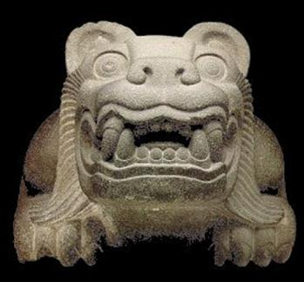
Different efforts search through the tradition of dance, herbalism, folk art, ethno-music, culinary arts and some "knowledge" traits. There are three important premises. The century-old tradition of "concheros" who keep the tradition in the courts of the churches and make music with strings and "shells". Groups of farmers and suburbanites that have managed to survive through the religious syncretism, in a marginal corner of creole culture and Dr. Guillermo Bonfil Batalla called the ''profound Mexico". Another current, more recent is that of the Mexico-north Americans (Chicano) that in the 1960s, in front of the struggle that kept African-Americans for their civil rights, the children of Mexican immigrants born in the U.S., placed their cultural roots in the "mythic Aztlán" and therefore "The Aztecs". And more recently, in the seventies, emerged in "downtown Mexico city", groups of "the Mexicanity", the Aztec dance or Warrior dance. All of this based on the mythical glorious past "the Aztec warriors and their grandiose Empire of Mexico-Tenochtitlan".
To all these a phenomena of the system of consumption of the "new age" segment was added, as there were characters such as Carlos Castaneda, José Arguelles, María Sabina and Gordon Watson, among the most significant. However, it was Carlos Castaneda that engrossed knowledge of the existence of the "Toltequity" through the "teachings" of a man of knowledge, i.e. a "Toltec yaqui", who was a member of one of the many lineages of knowledge that according to the author, have existed and continue to exist, but that the dominant culture does not know.
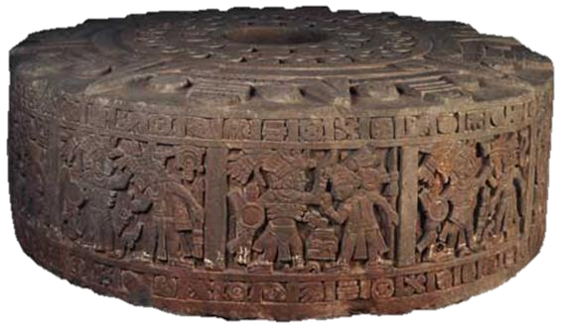
The work of Carlos Castaneda, translated into many languages and with higher circulation than the work of Gabriel García Márquez, introduced in the values of the wacky western society, the terms of "Toltec, warrior, nahual, man of knowledge, plants of power" and above all, give a "spirituality" light to urban people who have lived for generations in the denial of nature, community and spirituality. He gave to indigenous discredited and excluded cultures a different meaning and discovered values that have always existed.
The point is that this is the way in which the state and creole ideology has neutralized endeavors in pursuit of the essence of the identity of the mestizo majority in this country, on the one hand, to maintain the big lies and omissions in the official history on the most essential and important aspects of the civilization of the Anahuac, as it was the philosophical thought that generated more than a thousand years of splendor (200 bc to 850 ad) and that produced the highest level and quality of life for an entire people in the history of mankind.
Indeed, the spiritual destitution in which Mexicans of today live comes from the "conscious" ignorance of the ethical and moral values, as well as the community and spiritual principles that allowed this marvelous and apparently amazing human development.
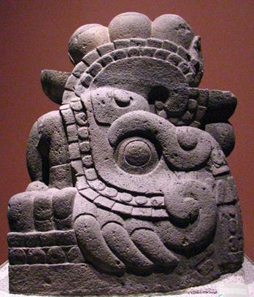
An impressive example of this condition is that: all ancient civilizations built pyramids without a previous plan. In the Anahuac, these impressive structures were not cities, fortresses, palaces nor "ceremonial centers"; instead, were centers of studies and research. In second place, by the number of pyramids built, is the civilization of Egypt with 110 pyramids, in Mexico, INAH only has open to the public 187 "archaeological sites" and each area has more than one pyramid. The problem is that when contemporary "Mexicans" visit them, they know nothing about the real and fundamental purpose of the construction of these wonders, as "uneducated foreigners" walk desolate as "zombies" among "the ruins", without knowing or understanding absolutely nothing. Ignoring the best of themselves, of their Cultural heritage.
And on the other hand, the creole neo-colonial State has maintained its "official history", not only in textbooks. The breath and the superlative exaltation to the mexica culture, implies a way to colonize intellectually. One of the reasons for this knowledge massacre is to deprive the people from the encounter with, and awareness of the values and principles of life of the ancient mother civilization. The creole ideology in power know that as long as the people keep in their psyche the "powerful Aztec warriors as their origin and that miscegenation is represented with the bastard son of Cortés and Malinche", we are completely neutralized. And it is precisely this catatonic state at the level of Cultural identity and historical memory, which allows the merciless exploitation of a meek and amnesiac people. Permanently extolling the foreign and disregarding and despising the own.
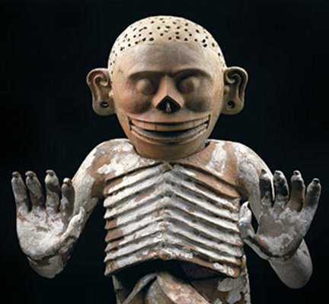
With all this it is not intended to demean and depriving the Aztecs of their cultural achievements. As with all the peoples of the Cem Anáhuac, they arrived migrating from the north and became civilized through the Toltecáyotl, which is a collective and ancient creation of all peoples, from what is today Nicaragua to Canada. Although they reach the Central Highlands in the Postclassical decadent (1272), they quickly took the remnants of the Toltecáyotl that would have survived the collapse of the high classical period (850 ad), assimilated it and melt it with their great strength and cultural force, the Mexica, as all the peoples of the world possessors of "the culture of the desert", have a staggering capacity of adaptation and resistance. In a short time, they cease to be tributaries and become a prominent group in the Valley of Anahuac.
Their problem is that their longtime Cihuacoatl called Tlacaelel (1398-1480), who was the "power behind the throne" (1428-1478), of three "Huey Tlatoani of the Excan Tlahtoloyan" (Triple Alliance), Izcoatl, Moctezuma Ilhuicamina and Axayactl, before the imperialist expansion and the threat of the destruction of the Fifth Sun, threatened every 52 years, according to the ancient Anahuac prophecy, changed the Toltecáyotl philosophical-spiritual precepts, took Quetzalcoatl out of the Tlaloc-Quetzalcoatl duality, and replaced him with their tribal God that came from the North, known as Huitzilopochtli. Tlacaelel took away one of the four Tezcatlipoca and replaced with Huitzilopochtli, as well as, he commanded the destruction of all ancient codices and created a new story, where the mexicas occupied the most important and central place.
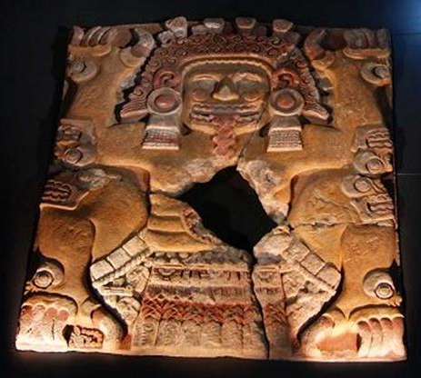
It was then that the spiritual development declined and was changed to a material development. In full development of the ideology that professor Alfredo López Austin called "Suyuano State". With these reforms, Tlacaelel guaranteed the "sustainability of the Fifth Sun" and named themselves "The people of the Sun". Culture materialized, war ceased to be "interior-personal-spiritual" and turned against neighboring states to submit them and impose large taxes. Ancestral schools became military academies, started to use the cacao as an instrument of change on the path to creating a currency. The exchange of articles to keep the cult became a pragmatic trade, began to hoard, private property was created and commenced the consumption of luxury goods brought from distant places and therefore began to create a very large gap between leaders, military, and religious classes favored by the system, and the macehuales, the people.
The creole neo-colonial ideology places the mexica people as the "most powerful and dominating of all Cem Anahuac". This is totally false, the Mexica were a people experiencing a severe ideological crisis and religious (for the Toltecáyotl transgressions) within the ruling class itself. But also, with strong problems with tributary states for the excessive tax burdens imposed. This is the real reason why, Cortes advised by the Malinche traitor, goes to Tenochtitlan looking for alliances with the mexica enemies, and as a "Quetzalcoatl's Captain", not as enemy-conqueror, causing on purpose a civil war among the peoples of the Central Highlands.
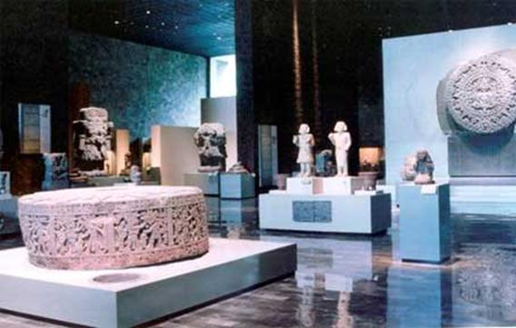
Far from ending the "war of conquest" on August 13, 1521, this date marks the beginning of the conquest of the Anahuac, which continues to the present day, especially with the resistance of the Maya, Yaqui and Zapotec people, among many others. An interesting point to mention is that the "conquest of the Anahuac", especially until the middle of the 16th century, was in charge of the Nahua peoples of the Central Highlands. Indeed, under "the usos y costumbres Zuyanos", the defeated people were to join the victors. In this way the mexicas, texcocans, xochimilcas, joined the tlaxcalans and spaniards in the conquest. Nahua peoples were those who carried the heaviest part of the conquest.
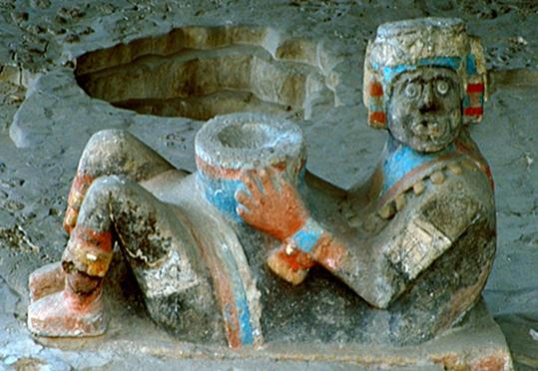
Finally shall say that although, in the decadent postclassical period, the anahuaca culture declined only in the philosophical-religious aspect, but human, scientific and artistic development maintained the high standards it had achieved in the classical period. This is evidenced by two things: the first is that the city of Tenochtitlan was the largest city in the world in 1519. It had all the urban, architectural and services of a present day city and that, at those times, no european city possessed them. As well as quality food, hygiene and health, educational and social organization of the people who lived in it.
Secondly, we can say that the mexica culture reached an amazing advancement in a very short time. From being nomadic, hunter-gatherer, became possessors of very rich culture with various expressions of knowledge. To illustrate the above, suffice to observe pieces carved in stone of the first construction phase of Tenochtitlan which are found in the Museum of historic downtown of Mexico City and those which are preserved in the National Museum of anthropology and history of the last phase. The technical and aesthetic quality of Coatlicue or the stone of the Sun, can compete with any other culture in the world.
So the mexica culture, is and should be taken as a part of the ancient civilization of the Anahuac. Since the founding of Mexico-Tenochtitlan to its destruction (1325 to 1521), 196 years passed, and of these, for only 81 years they had a relative power. However, the Cem Anahuac civilization has eight millennia of existence, since the invention of agriculture until today and, of these a thousand years were a luminous splendorous civilization thanks to the Toltecáyotl.
We cannot and must not, search and settle the pride of our mother civilization in the mexica culture. If we do, we are only being victims of the creole neo-colonial State. We require searching in the distant past of ourselves. We need to decolonize the mind and hence history. A critical and analytical thinking is required to put an end to so many lies and perverse misrepresentation. We require re-thinking our history and make it our own, not of the conqueror. We cannot get out of the dungeons of the prison of colonization with the ideas and precepts of our jailers. Decolonization is to dignify. It is to find the true face and the flowered heart of our ancient grandparents.
The difficult is not to do it, but to imagine it.
Guillermo Marin
Oaxaca, October 2014.

www.toltecayotl.org
www.aquioaxaca.com
http://tolteca-guillermomarin.blogspot.mx/
tigremarin@gmail.com

Bibliografía.
Alva Ixtlilxóchitl, Fernando de. Obras Históricas. UNAM/IMC. Méx. 1997.
Bonfil Batalla, Guillermo. México profundo, una civilización negada. CIESAS/SEP. Méx. 1987.
Castro, Felipe. La rebelión de los indios y la paz de los españoles. CIESAS/INI. Méx. 1996.
Cortés, Hernán. Cartas de Relación. Purrúa. Méx. 2007.
Guerrero, José Luís, Flor y Canto del nacimiento de México”. Librería
Parroquial de Clavería. Méx. 1990.
Lenkersdorf, Carlos. Aprender a escuchar, PyV. Méx. 2008.
Filosofar en clave tojolabal. Purrúa. Méx. 2005.
Lafaye, Jaques. Los Conquistadores. Siglo XXI. Méx. 1970.
López Austin, Alfredo. Cuerpo Humano e Ideología. UNAM. Méx. 1980.
La educación de los antiguos Nahuas. El Caballito/SEP. Méx. 1985.
Hombre Dios, religión y política en el mundo Náhuatl. UNAM. Méx. 1989.
Marín, Guillermo.
Historia Verdadera del México Profundo.
http://toltecayotl.org/tolteca/index.php/2014-03-30-23-46-16/libros/402-historia-verdadera-del-mexico-profundo
Mitos y Fantasías sobre los aztecas, los españoles y la conquista de México.
http://toltecayotl.org/tolteca/index.php/2014-03-30-23-46-16/libros/694-mitos-y-fantasias-de-los-aztecas-los-espanoles-y-la-conquista-de-mexico
Los Guerreros de la Muerte Florecida
http://toltecayotl.org/tolteca/index.php/2014-03-30-23-46-16/libros/399-los-guerreros-de-la-muerte-florecida
Romerovargas Iturbide. Ignacio, Los Gobiernos Socialistas del Anáhuac. Edición de autor. Méx. 1978.
Soustelle, Jaques. La vida cotidiana de los aztecas en vísperas de la conquista. FCE. Méx. 1983. El universo de los aztecas. FCE. Méx. 1982.
Séjourné, Laurette. Pensamiento y religión en el México antiguo. FCE. Méx. 1957.

Gachupin. In the colonial caste system of Spanish America and Spanish Philippines, a peninsular was a Spanish-born Spaniard or mainland Spaniard residing in the New World or the Spanish East Indies, as opposed to a person of full Spanish descent born in the Americas or Philippines, who were known as creoles. The word "peninsular" makes reference to the Iberian Peninsula in Europe, where Spain is located.
It is a Nahuatl name derived from the words "cē" one/whole and "Ānāhuac", which in turn derives from the words "atl" (water) and "nahuac", a locative meaning "circumvented or surrounded". Hence, the name can be literally translated as "land completely surrounded by water", or "[the] totality [of what is] next to water". The term refers to the conscience that the Mexica had of the American territory they knew, surrounded by two great oceans, the Atlantic Ocean and the Pacific Ocean.
Bernardino de Sahagún (1499 – October 23, 1590) was a Franciscan friar, missionary priest and pioneering ethnographer who participated in the Catholic evangelization of colonial New Spain (now Mexico). Born in Sahagún, Spain, in 1499, he journeyed to New Spain in 1529, and spent more than 50 years in the study of Aztec beliefs, culture and history. Though he dedicated himself primarily to the missionary task, his extraordinary work documenting indigenous worldview and culture has earned him the title “the first anthropologist.” He also contributed to the description of the Aztec language Nahuatl, into which he translated the Psalms, the Gospels and a basic manual of religious education.
The name cihuacoatl was used as a title for one of the high functionaries of Tenochtitlan, the Aztec capital. The cihuacoatl supervised the internal affairs of the city as opposed to the Tlatoani, the Aztec ruler, who oversaw the affairs of the Aztec state. The cihuacoatl commanded the army of Tenochtitlan, oversaw sacrifices to the gods and was the senior advisor to the emperor. During the course of the 15th century AD Tlacaelel served as cihuacoatl under four emperors—Moctezuma I, Axayacatl, Tizoc and Ahuizotl.
The Mexica Triple Alliance (Nahuatl: Ēxcān Tlahtōlōyān, or Aztec Empire began as an alliance of three Nahua city-states or "altepetl": Tenochtitlan, Texcoco, and Tlacopan. These city-states ruled the area in and around the Valley of Mexico from 1428 until they were defeated by the combined forces of the Spanish conquistadores and their native allies under Hernán Cortés in 1521.
Tepito is a barrio located in Colonia Morelos in the Cuauhtémoc borough of Mexico City bordered by Avenida del Trabajo, Paseo de la Reforma, Eje 1 and Eje 2. Most of the neighborhood is taken up by the colorful tianguis or open-air market. Tepito's economy has been linked to tianguis or traditional open air markets since pre-Hispanic times.
Nuestra Señora de la Santa Muerte or, colloquially, Santa Muerte (Spanish for Our Lady of the Holy Death), is a female folk saint venerated primarily in Mexico and the Southwestern United States. A personification of death, she is associated with healing, protection, and safe delivery to the afterlife by her devotees. Despite opposition by the Catholic Church, her cult arose from popular Mexican folk belief, a syncretism between indigenous Mesoamerican and Spanish Catholic beliefs and practices. Since the pre-Columbian era Mexican culture has maintained a certain reverence towards death, which can be seen in the widespread commemoration of the syncretic Day of the Dead. Elements of that celebration include the use of skeletons to remind people of their mortality.
Francisco Javier Clavijero Echegaray (sometimes Francesco Saverio Clavigero) (September 9, 1731 – April 2, 1787), was a Novohispano Jesuit teacher, scholar and historian. After the expulsion of the Jesuits from Spanish colonies (1767), he went to Italy, where he wrote a valuable work on the pre-Columbian history and civilizations of Mesoamerica and the central Mexican altiplano.
Mexican term colloquially used to refer to someone who took a payment in exchange of his views and opinions, mostly politicians.
The Concheros dance, also known as the Chichimecas, Aztecas and Mexicas, is an important traditional dance and ceremony which has been performed in Mexico since early in the colonial period. The dance has strong visual markers of its pre Hispanic roots with feathered costumes, indigenous dance steps and indigenous instruments such as drums. However, the name Concheros comes from a type of lute made with an armadillo shell, showing Spanish influence.
Toltecayotl or Toltequity, (tōltēcāyōtl) is a náhuatl language word derived from "tōltēcātl" which was used by the Aztecs to refer to the members of the Toltec civilization that preceded them in the basin of Mexico, as well as a generalized meaning of "artisan".
The Yaqui or Yoeme are Native Americans who inhabit the valley of the Río Yaqui in the Mexican state of Sonora, Mexico and the Southwestern United States. The Pascua Yaqui Tribe is based in Tucson, Arizona. Yaqui people also live elsewhere in what is now the southwestern United States, especially California.
Carlos César Salvador Arana Castañeda (December 25, 1925 – April 27, 1998), was a Peruvian-American author with a Ph.D. in anthropology. Starting with The Teachings of Don Juan in 1968, Castaneda wrote a series of books that describe his training in shamanism, particularly a group that he called the Toltecs.
Tlatoani is the Nahuatl term for the ruler of an altepetl, a pre-Hispanic state. The word literally means "speaker", but may be translated into English as "king". A cihuātlahtoāni is a female ruler, or queen regnant.
Tezcatlipoca was a central deity in Aztec religion, and his main festival was the Toxcatl ceremony celebrated in the month of May. One of the four sons of Ometeotl, he is associated with a wide range of concepts, including the night sky, the night winds, hurricanes, the north, the earth, obsidian, enmity, discord, rulership, divination, temptation, jaguars, sorcery, beauty, war and strife. His name in the Nahuatl language is often translated as "Smoking Mirror" and alludes to his connection to obsidian, the material from which mirrors were made in Mesoamerica which were used for shamanic rituals and prophecy. Another talisman related to Tezcatlipoca was a disc worn as a chest pectoral. This talisman was carved out of abalone shell and depicted on the chest of both Huitzilopochtli and Tezcatlipoca in codex illustrations.
The mācēhualtin were the commoner social class in the Mexica Empire. During the reign of Moctezuma II (1502–1520), they were banned from serving in the royal palaces, as this monarch widened the divide between pipiltin (nobles) and macehualtin. As Aztec society was in part centered around warfare—every Aztec male received basic military training from an early age—the only possibility of upwards social mobility for mācēhualtin was through military achievement—especially the taking of captives. After the Spanish conquest, the Nahuatl word mācēhualli was adopted in colonial Spanish as macehual, and was used all over New Spain as a synonym for "commoner," "subject," and "native."
The habits and customs are forms of particular behavior assumes a whole community and which distinguish it from other communities; as dances, festivities, their meals, their language or their craft.

