TOLTEC PEDAGOGY
Education philosophy in ancient Mexico

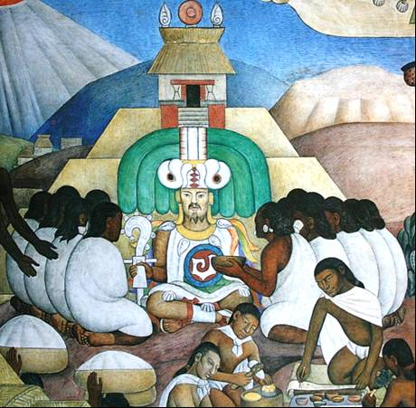

Guillermo Marín
2009-70312090100-01 (Spanish Version)

INDEX

 | Introduction. | 4
1.- | The Anahuac civilization. | 6
2.- | Toltecáyotl. As knowledge school. | 8
3.- | Toltecs. As knowledge degree. | 10
4.- | The pyramid of human development. | 13
5.- | Education as society development intersectoral element. | 16
6.- | Education as cultural legacy. | 18
7.- | Family education and the Huehuetlahtolli. | 20
8.- | Anahuac education foundation. | 28
9.- | Telpochcalli and Tezcatlipoca. The house of the youth & the interior enemy. | 31
10.- | Cuicacalli. House of song, artistic education. | 37
11.- | Calmécac & Quetzalcoatl. The house of measure and the equilibrium wisdom. | 39
12.- | The Tlamachtitlani. The teacher. | 42
13.- | The students, boys and girls. | 46
 | Bibliography | 51

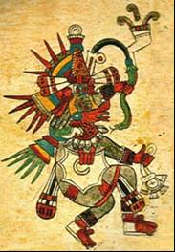

“That new call for independence should be
first of all, a call for education.
To an education model that seeks to suppress all sorts
of inferiority admission that, as of the european invasion irruption, has been tried to place upon us”

Rubén Bonifaz Nuño.

First electronic edition: 2009
All rights reserved: Guillermo Marín Ruiz
Editorial www.toltecayotl.org
Cover: Diego Rivera mural fragment at National Palace.
2009-70312090100-01

Introduction.

Education is one of the issues mostly dealt with by demagogues who are in economic and political power. It is repeatedly stated that education is the future of peoples. But reality tells us that, with the exception of a few countries, education is insignificant on budgets and priorities for the rich and poor nations on the planet.

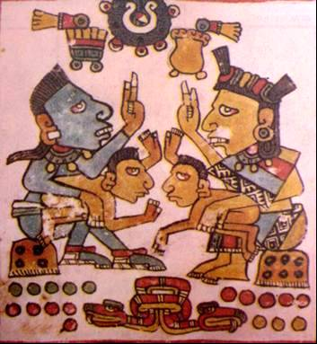

On the other hand, instruction and education has become deliberately confused. Instruction is based on knowledge transmission and education in values transmission. Every day individuals leave schools trained in advanced scientific and technological knowledge, but at the same time, devoid of values. And an instruction without values, leads to social and environmental destruction.

The choice is very old. Educate for life or train for work. Since the Industrial Revolution, education has been losing ground to instruction. Individualism, utilitarianism and pragmatism have imposed, over the humanist, spiritual and community senses. Education has become a business, directly and indirectly, and in means of subjugation and alienation.

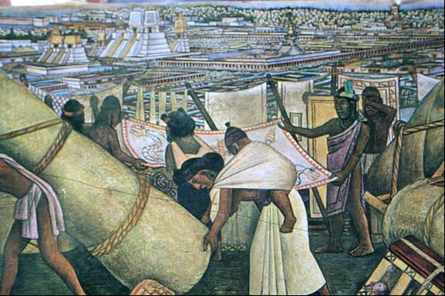
In Mexico we have a millenary educational legacy, unique in the world.
But due to colonization processes, has been denied the national teacher system for the development of educational models that are closer to what we have been and are as a people. It is essential that teachers cease to import new theories, and instead, investigate and discover this educational legacy to which he, to improve their professional performance.

1. - The Anahuac civilization.

Within the six most ancient civilizations with autonomous origin in the world, is the Anahuac civilization. With more than seven and a half thousand years, since the agriculture invention up to the European invasion; and from the northern part of what today is the United States, down to Nicaragua in the southern part.

The Anahuac civilization was the sum of many different Nations and original cultures, in time and space, but totally united by a single philosophical, religious and cultural matrix called Toltecáyotl. Its historical time has been divided by researchers into three periods: a formative Preclassical (Olmec), a Classic of splendor (Toltec) and a decadent Postclassical (Mexica or Aztec).

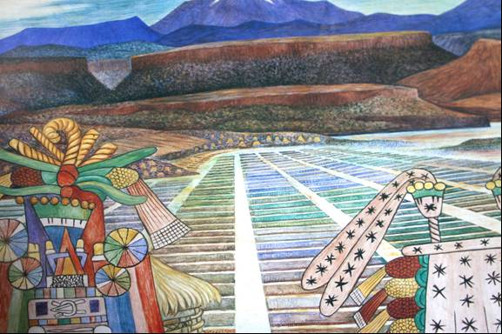

Among the most important and characteristic features of this civilization will point out the following four: the invention of their essential food grain, maize. A common philosophical and religious root shared by all peoples across their time and space. An absolute integration and correlation between celestial mechanics, mathematics, environment and their world and life conception. And the creation and development of an educational, public, compulsory and free, system during at least three thousand consecutive years.

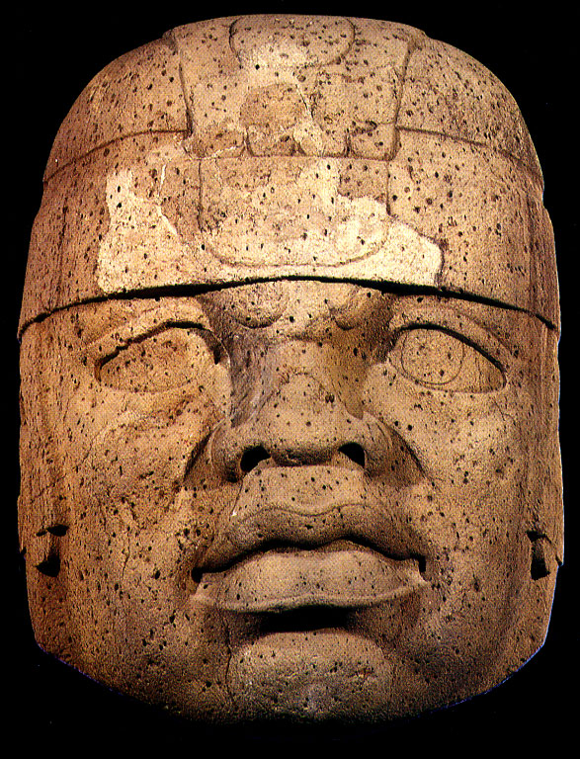
However, due to mental and cultural colonization, the Mexico ancient past has been sentenced to denial and distortion. Denial comes from the creole idea that "the nation" and its "history", begins with Europeans arrival. The seven and a half millennia are only "pre-Hispanic history," i.e. before us, erasing and devaluing the above.

Distortion, because the only reference considered is the Mexica or Aztec culture. They exalt it as the highest development apex of the Anahuac, when this is completely false. The Aztecs barely had power as of Moctezuma Ilhuicamina in 1440 and his power was based on the Quetzalcoatl wisdom and teaching transgression.

The Toltec spiritual character education system became, during the last 80 years of the Aztec culture, a military squad training system, to perform imperialist wars which were designed to gather prisoners for sacrifice and to impose heavy taxes on vanquished peoples. This essay will discuss education during the classical period 200 BCE to 850 CE.

2. - Toltecáyotl.

All the large and ancient civilizations, have guided the long road of their "human development" through a complex and elaborate structure of knowledge that explain and give sense to the individual life, the family, community and State. All these civilizations have invariably sought to answer three basic questions which are the foundations where all human development rises: who am I, where do I come from and where am I going?

This explanation of the fundamental existence reasons is what is known in the West as a philosophy. The human being is not resigned to be born, grow, reproduce and die, seeks to find a transcendent meaning to their thoughts, feelings and actions, in short, to their life. This quest for the meaning of life, shared by a group of people, is what gives continuity and direction to a civilization over time.

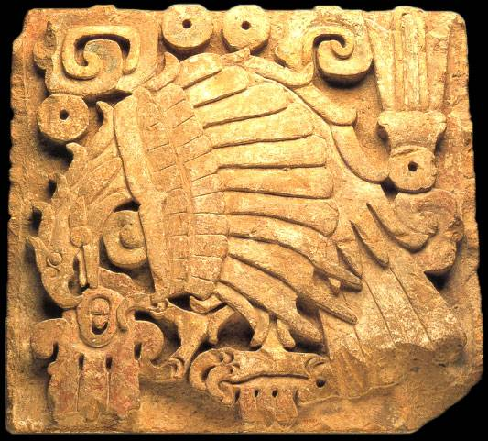

The ancient inhabitants of what today is Mexico initiated and developed from the very same origin of time, a number of ideas on the meaning of life. Over time they were polishing, filtering and systematizing this complex system that they called “Toltecáyotl”, which can be translated as “the highest set of Toltec creations “, the objective goal of the Anahuac civilization.

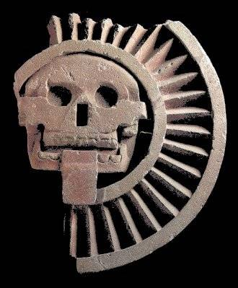

Toltecáyotl is the set of knowledge aimed at achieving existence spiritual transcendence, from reaching "the balance of the four life directions", i.e. the spiritual aspect with the material aspect, the rational aspect with the intuitive and that is iconographically represented with the so-called “Quetzalcoatl Cross" or quincunxe.

The Toltecáyotl has the same philosophical value and the same human depth as Hinduism, Buddhism and Zoroastrianism. Wisdom that for thousands of years has guided the people’s existence, which conforms the Anahuac civilization throughout eight millennia, since the agriculture invention until our days.

This ancestral set of knowledge, which over time has accumulated in "the gene bank of cultural information", in the historical memory, and gives the children of the children an "own face and a real heart", which distinguishes them and differs them from other peoples of the world.

3. – The Toltecs.

The Toltecs were not an ethnicity nor a culture. They were instead "a degree of knowledge", reached through hermetic and selective schools atop the upper vertex of the Anahuac civilization. So "the Toltec" belonged to all peoples of the Anahuac and the so-called knowledge centers, which we know today as "archaeological sites", were the places where they investigated, practiced and taught complex and deep knowledge to transcend the limited material living spaces and penetrate the unfathomable mysteries of the spirit and energy.

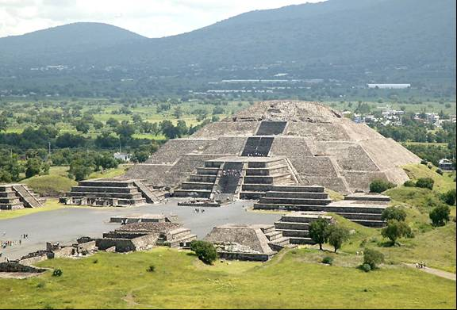

The Toltec were not civil, religious or military authorities. They were instead, teachers familiar with millennial knowledge that versed on the ability of the human being of self-conceiving as an energy charge, and understanding the world around them as an energy conglomerate and perhaps, most importantly, conceiving themselves as "energy creators ".

The Toltec teachers (men and women), lived completely separated from the Anahuac inhabitants. Knowledge centres were closer to the eastern cultures monasteries. Such that the Toltec, especially during the classical period, passed the values, principles and knowledge to all the peoples and cultures, that guided the human Anahuac development path in the Anáhuac. This is the reason why, in the Anáhuac we can find a wonderful and diverse cultural plurality, but at the same time, amazingly linked by a same philosophical-cultural matrix.

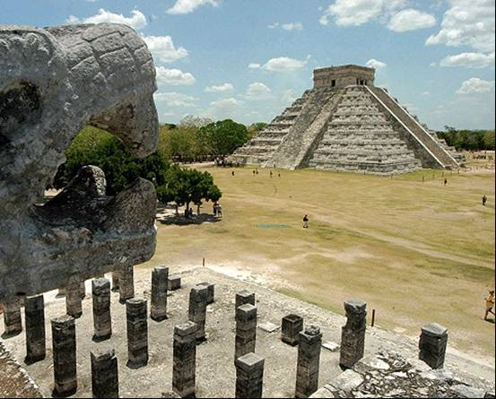

With these values and knowledge the leadership of the different cultures of the Anahuac was formed. The leaders, organizers, managers, priests and teachers, received during the classical period, the wisdom structured in the Toltecáyotl, to guide their peoples in search of higher social projects.

The Toltecáyotl was present in all knowledge, being and doing branches of the Anahuac peoples. Its universal values and guiding principles were demonstrated in the individual, family and community construction. The highest Anahuac social purpose was based on the Toltecáyotl, as well as the four elements of the "Anahuac development pyramid": the food system, the health system, the educational system, the social organization system and the legal regime, were fully united and harmonically linked by the Toltecáyotl.
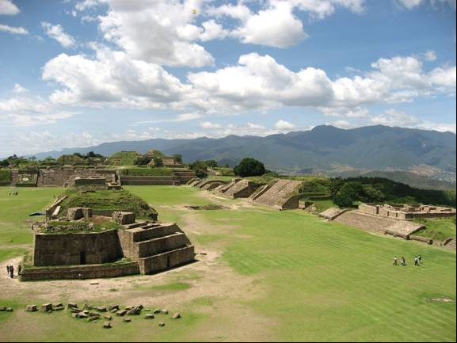
During the three millennia in which the Anahuac educational system operated, it probably had variants of the "form", but not the "concept". Because of different cultures, environment, languages and other factors, the education must have had variations, as it is today, but its humanist and spiritual essence, only was changed by the Aztecs, during the last 80 years before the Europeans arrival.

4. - Anahuac human development pyramid.

During the Preclassical period, comprising since the agriculture invention approximately from the year 6000 BCE, up to 200 CE, flourished the most important bases of human development in the Anahuac.

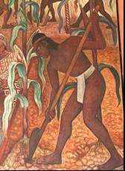
Indeed, since the time ancient Mexicans ceased to be: nomads, hunters and gatherers, thanks to the agriculture invention, up to the point they had the basis to start their development fullness, approximately five thousand eight hundred years went by. It was during this long training period that the Toltecáyotl is born, the knowledge structures are created, systematized in the four systems that make up the development pyramid.

The food system, that goes from plant domestication, corn invention, hydraulic engineering, animals domestication, the profound knowledge of different plant species, animals, insects and minerals, up to creating an immeasurable cuisine culture, with a high nutritional level. This prodigy became diversified throughout the Anáhuac, involving different and varied ecological niches. Producing energy and free time to perform their elevated social purposes.

Organization

Education

Health

Food

The health system, as well as the food system, included not only a deep and varied knowledge of plants, animals, insects and minerals from the Anahuac biodiversity, but it was based on a deep and complex knowledge and study of the human body. Reaching energy fields of their perception as live conscious beings. Fostering vitality, health and harmony to the peoples of the Anahuac.

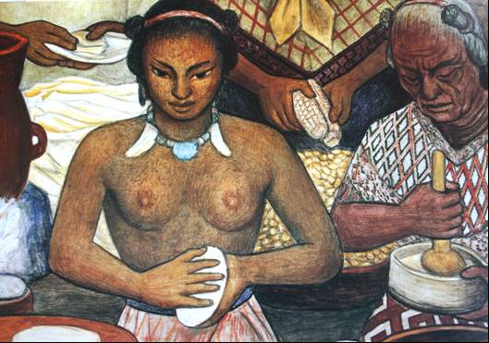

The educational system, ranging from the basic essential family education, through school education, instruction and training in educational institutions, up to very high levels of energy research and spiritual development in the Toltec knowledge centers, known today as "archaeological sites". Creating the possibility of maintaining a social purpose, through at least three thousand years consecutively, fostering continuity, homogeneity and direction to the civilization model.

The social organization system and legal regime, ranging from ancestral family and community principles and ethical and moral standards, passing through production and trade relations, solidarity and social responsibility, forms of community and state administration; up to a very complex system of laws, rules, uses and customs that embodied free work by the community, the stewardships and charges system, which allowed the orderly and balanced community life as well as relationships and exchanges with other communities or states.

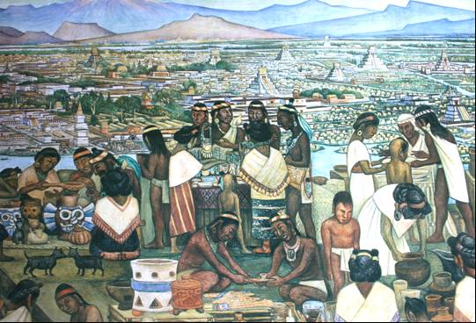
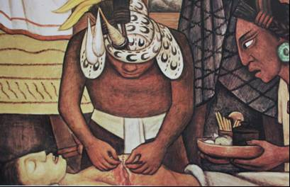
The diversity and complexity of these four systems, which were each fully interelated among themselves, forming an indissoluble unity, were founded in the Toltecáyotl, root and essence of the Anahuac civilization.

5. - Education as society development intersectoral element

One of the most outstanding and important features of the Anahuac civilization, was the possession of a free public and compulsory education system. Unlike other mother civilizations mother, the anahuaca placed a special emphasis on education.

"Nothing else I admired most and seemed more worthy of praise and memory than the care and order to raise their children, by the Mexicans" father José de Acosta (1540-1600). Nat. and Moral history. Sixth Book, chapter 27.

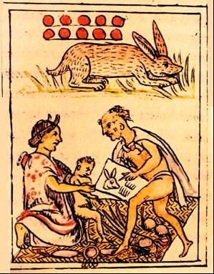
One could argue that civilization itself was based in education. No other humanity ancient people acted this way. With full coverage, mandatory for parents and authorities, and with a sense of being totally free. This education "conscience and concern" in which the Anáhuac inhabitants lived for three thousand years, is now seldom seen, very few countries has it. Because it is not only wealth and national power, but goes beyond, gravitates on a very high humanist horizon. So today we find very rich and powerful countries where public, private and family education occupies a secondary place in the society and state priorities.

The ancient Mexico education was an indispensable part of humanization. The Tollan or the city was conceived as educated persons living in community, with a very high objective or social purpose and shared by all members, from a millennial educational process, in which community "service" was essential. In this way the constructive efforts long periods of the Anahuac can be understood. As for example Monte Alban, in today’s Oaxaca State.

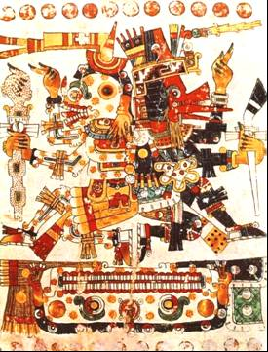
In fact, Monte Alban started its first constructive phase in the year 500 BCE and was destroyed and abandoned in the year eight hundred fifty CE. Which meant a sustained constructive effort during one thousand three hundred and fifty years, in which the architectural-constructive purpose remained unchanged, which implies that "the ideas, objectives and aspirations" by which millions of tons of Earth and stone were moved, maintained its validity unchanged. This could only be achieved through education. The telpochcallis, the cuicacallis and the calmécas maintained the social purpose in children and young people, from 500 BCE until 850 CE.

Education in its broadest sense was totally immersed in the social fabric. The same applied at home and in public spaces. In the family and state objectives. Education was present in obtaining food, in its preparation and consumption. The individual had to learn the secrets and knowledge of the food miracle. The same way it applies to health.

But the same applies to social organization. Ethics and morality, understood as personal and social value judgments, are transmitted-learnt through direct and indirect education, formal and informal processes. It is then education, which enabled the individual, the family and the community, to feed, sustain health, organize and live in harmony in society. But more importantly, education is what allows maintaining the social purpose order and achieve the higher abstract projects of a civilization over time.

6. - Education as cultural legacy.

Cultural heritage is divided into two areas, the tangible cultural heritage, which refers to "objects", such as pyramids, steles, ceramic, codices, etc. And intangible cultural heritage, which refers to "subjects", namely persons. This heritage is perceived in the knowledge, feelings, traditions, uses and customs of a nation. The particular way of understanding the world and life.

Intangible cultural heritage is the most important, in as long as, is the "producer and reproducer" of the tangible heritage. In this way, education can be considered the most important property of cultural heritage, and consequently, the most valuable cultural heritage to build a more humane, fair and harmonious future.

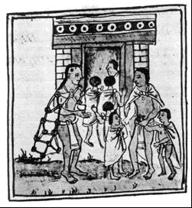
Of the six humanity oldest civilizations with autonomous origin, the Anahuac civilization was the only one that created a public, compulsory, free and with a total coverage educational system. The French scientist Jacques Soustelle, in his book “The Aztecs universe", noted in 1955: "It is remarkable that at that time, and on that continent, an indigenous American people have practiced compulsory education for all and that there was not a single Mexican child from the 16th century, whatever their social origin, which was deprived from school." In Europe the first public, compulsory and free education system was implemented in Italy in 1596.

If we assume that education transmitted values and that, in the Anahuac remained present with total coverage, at least for three thousand consecutive years. We can explain the reason why in Mexico, people who have generations of "not attending school" or may have not completed grammar school, "are highly educated people, with strong ethical and moral values".

This values education (non-formal and non-school), transmitted through ancestral culture, allows individuals, families and peoples, to have better eating habits and to eat "out of nothing", the same in a desert as in a forest. But also, this education transmitted in the traditions, uses and customs, allows them to have good hygiene habits and healing methods, which include plants, insects, minerals and ancient techniques. These skills are embedded in construction, planting, reforestation, community organization and justice delivery methods and techniques.

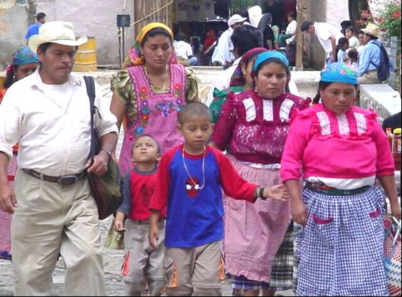
Finally, education also prepares from childhood to, individuals of a community to "serve", to obey and respect hierarchies, learning that the Community interest is more important than the individual.

7. - Family education and the Huehuetlahtolli.

The Toltec family concept is clearly visible in the Nahuatl word "cencalli" where - cen - means "entirely together" and calli -house-. From where it is assessed that cencalli means "the large house of those who live entirely together".

Another word that allows understanding the Toltec family dimension is - cenyeliztli - understood as a "status or nature of those who live entirely and jointly". Finally, to understand the family concept we need to remember the word - calpulli-, meaning "great House", which implies a set of families who live entirely and jointly. The family represents the nucleus base of the individual conscience; the second will be the community. This is the reason why the education essence emerges from womb. The father and the mother shall have as fundamental objective the children education, in the Matritense Codex of the Royal Palace, we take these descriptions:
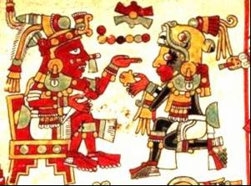
The father of people cares for all,
is compassionate, cares,
prevision is his,
he is the one giving support,
él es el que da apoyo,
with his hands protects.

Breeds, educates his children
Teaches them, admonishes them
shows them how to live.

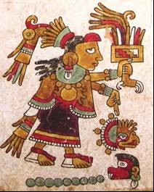
Places them before a large mirror,
makes see themselves in a two face mirror.
Is as a thick smokeless torch.

…

The family mother:
Has children, breastfeed them.
Her heart is good, watchful,
diligent, digs the earth,
has spirits, watches.
With her hands and heart, strives,
educates her children,
cares for all, takes care of all.
Cares for the little ones.
Serves everyone,
strives for all, nothing neglects,
preserves what she has,
does not rest.

As is seen the main parent attribute is children education. Indeed, children were loved and wanted by family, relatives and the community. From the moment of birth a series of ceremonies began with ancestral speeches, where all were reminded, again and again, the values and principles.

“Children education began the day of their birth with speeches by the parents and relatives who predicted their fate. Although regarded as small adults and citizens with all the rights from the moment of birth, children were treated with great affection and were called "priceless jewels" or "precious feathers".

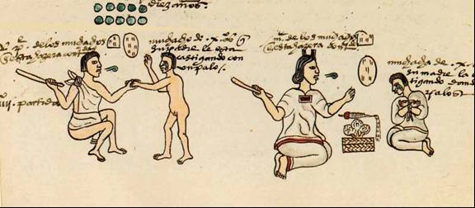

Domestic education, which began after weaning, at three or four years, was intended to induce adulthood techniques and obligations as soon as possible in the child. A world in which manual labor was common to all, offered children the opportunity to participate in adult activities much earlier than, for example in our mechanized culture. Parents supervised the training of boys and mothers instructed girls.
Up to six years old they listened to frequent and repeated homilies and advice, learned the use of household implements and did domestic work. Children received work as soon as they walked and an infant was made to carry small wooden loads; over time the weight increased and had more housework chores, carrying water and firewood, keeping fire and sweeping. The home education was divided according to sex: the father taught the son duties, while the mother instructed girls in corn milling to make tortillas and weaving clothes fabric.
Aztec children were constantly badgered with lengthy speeches about their fate and their moral and ethical duties." Max Shein, Pre-Columbian child. México. 1986.

Respect for parents and grandparents, as well as to older siblings, the relationship with extended family, i.e., uncles, aunts, political relatives, but above all, with godparents, who had at various childhood and youth stages, a "commitment" with the education of the Godson, was fundamental in the educational development of the child.
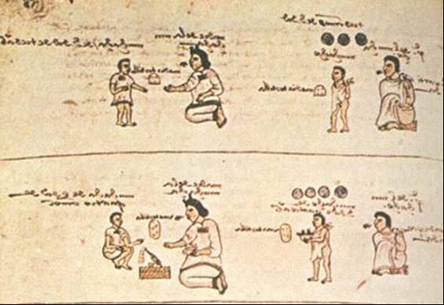

The children were immediately integrated, as a very valuable member to the social and family life. There was a total sense of respect for the infant, both for a cultural value fully admitted as a community, by a number of human beings integrated by parents, grandparents, godparents, uncles, that supported them. In this nucleus the values, principles and attitudes that govern the rest of his life were formed. The home education was practical and by imitation. The example of the family nucleus was basic, starting with the parents.

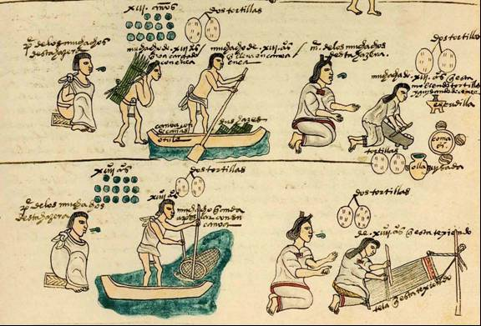

Parents taught their sons, at an early age, to comply with all the male obligations with the household and the community. In addition to incorporating them into the work made by the father, such as agriculture, ceramic, hunting and fishing, etc., plus community activities, such as collective agricultural work, construction and repair of temples, public buildings, canals, roads, bridges, etc. Mothers disciplined their daughters in household chores. They learned at an early age to make tortillas, embroidery, weaving and spinning, to wash and maintain the house scrupulously clean. As well as community chores as cleaning temples and public buildings, prepare food for dignitaries, officials and visitors, as well as collaborating in the preparation community meals.

In addition, the child is fully incorporated into the family, social and community life. Whether family festivals, their calpulli or community, religious or profane, in no space the anahuaca child was in the way or not wanted. Reason why the children knew profane and religious rituals. Another feature of this education was that infants learned to feel useful and to participate in family responsibilities. The children upbringing in the household was an honor and a great responsibility. Mothers breastfed children for up to three or four years.

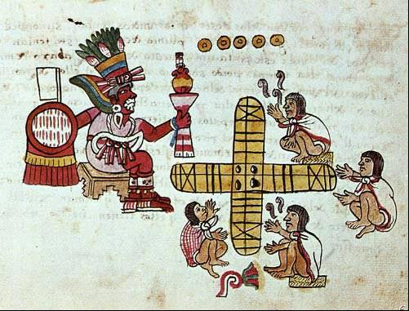

An important space was occupied by games, toys and sports on education of children and adolescents in the Anahuac. Few civilizations developed so many activities that not only were clever and funny, but it that transmitted values such as the ability to rationalize, team work, development of physical skills and knowledge of some rituals. The ball game, the teocuahpatlanque "Voladores de Papantla", Trompo or pepetotl, the patolli, tololoque, cocoyocpatolli, chichina, xocuapahpotolli "game of wooden sticks with the feet", matatena, papalote, cane ball game, clay wood and fabric articulated dolls, pottery animals with a wheel base, puppets, musical instruments, wrestling, athletics and hunting and fishing, among many others.
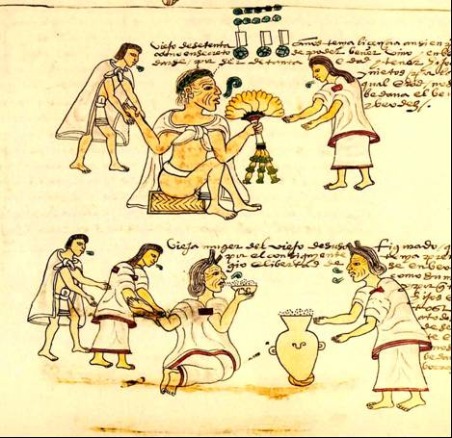
However, of what little remains of ancient Mexico education, it can be asserted that "Huehuetlahtolli" or the elders discourse is the most illustrative instrument that allows us to know the values that were transmitted daily to children and young people.

In them, is a millenary tradition of values to guide the formation of an individual, which was polished over the centuries and which contains the life wisdom and experience of a civilization. The Huehuetlahtolli is a values, principles and attitudes decalogue, that children and young, will have to practice in the world and life, at intimate, family and community spaces.

"Conversation or appeal from a father to his son.
My son, created and born in the world by God, in whose birth we your parents and relatives put our eyes. You've born and lived, and emerged as a chick hatch and grew like it; you rehearse the flight and temporary exercise. We do not know how long God will want us to enjoy such a precious jewel. I came, son, carefully, and entrust to God that created you, to help you, because he is your father who loves you more than me. Yearn to him day and night, and place your thoughts in him. Serve him with love, so that he favors you and free you from dangers. To the image of God and his things have much reverence, and pray in front of him devoutly and participate in his festivals.
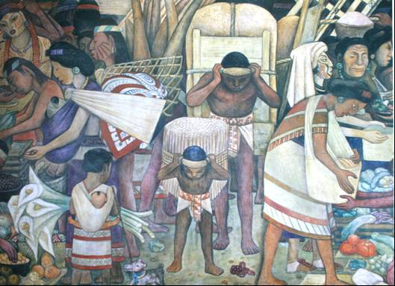
Revere and greet the elderly, not forgetting minors. Do not act as mute, and be sure to comfort the poor and afflicted with sweet and good words. Honor all and more so your parents, to whom you owe obedience, service and reverence, and the son that does not do this won't develop well. Love and honor all, you will live in peace and joy. Do not follow the crazy that will not obey his father nor revere their mother, but as animals leave the straight path, and as such, will not reason, nor hear doctrine, or are given to correct anything… Do not go out or enter before elders; whether sitting or standing, wherever they are, always give them preference, and revere them.
Do not you speak before them, nor cross their path ahead, so that others do not see you are spoiled. Do not eat first, before serve others, because then will reach the Gods grace and the elders. If something is given to you, even if it is of little value, do not undervalue, nor be angry, do not leave the friendship you have, because the gods and men you will want you well. Don't take nor reach other women, or otherwise be vicious, because you shall sin against the gods, and you will do much self-harm. You're still very tender to marry, like a chick, and sprout as a growing spike. Suffer and hope, because already grows the woman good for you: pole in the will of God, because you don't know when you will die. If you want to marry, let us first know, and do not dare not do it without us. Look, son, do not be a thief, nor gambler, because you fall in great disgrace." Alfredo López Austín. La Educación de los antiguos nahuas I. Méx. 1985.

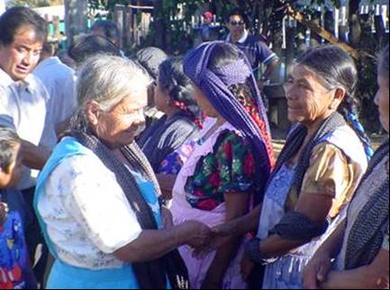
As it can be appreciated in this Huehuetlahtolli, fragmen, the stringent rules were ethical and moral guided social interaction. The careful speech, firm but loving, indicates the son a way of behaving in life and in the world. These appeals were memorized and transmitted from parents to children for centuries, so it remained in the collective subconscious of the sons of the sons of the old grandparents, Mexicans of today, a standard of conduct, education acquired through the centuries of exercise from generation to generation applied at home and in popular culture.

This educational treasure is still alive and existing in Mexican families, comprising education, which is transmitted orally and by example, within families. Requires reassessing and dimensioning this cultural legacy to support school classroom education.

8. - Anahuac education foundation.

If the Anahuac civilization had for at least three thousand years, an educational system, necessarily those who one day invented the corn, the mathematical zero or the perfect count of time, inevitably had to have a deep and polished philosophical sense on education. The tlacahuapahualiztli concept, which means "the art of raising and educating men", speaks of this deep cultural Anahuac heritage.

This sense started from the human being conception, education beginning and end. The human being was divine creation, perfectible and in constant evolution. The Teotihuacán gods sacrificed for them and their world. The Fifth Sun era was lived, which had been preceded by four previous Suns, in successive creation-destruction, always had the human being, their food and their society, in a process of constant evolution.

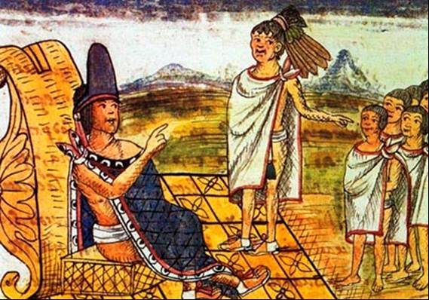

Another human being feature was that he possessed a great responsibility for development and equilibrium of the world he lived in. The common human being was called "macehual", which means, "the deserving" of the sacrifice of the gods. Somehow, this "deserving" was a "little helper" of divine forces which had created the world. His life had a sacred meaning, insofar as he could fully comply with this mission-responsibility. This "help" was provided by humans by being virtuous and compassionate, fearful and grateful of the divine in everyday life. Fulfilling scrupulously their duties with family, the community, the "dear mother" (Earth) and the Supreme divinity, "he for who they lived".

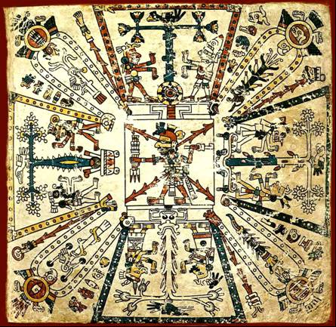
"The hypothesis I am raising meets the purpose of testing the unity of our original culture, unity that so far has been assumed without concern for the evidence that support it; In addition, it comes to explain, among other things, the irrepressible dynamism characteristic of that culture.

Because accordingly, men as the engine and starting material for the world creation, assumes thereafter his creative role as a permanent obligation. Creation is not an instantaneous event, but an endless process. Men have to comply without interruption, taking upon him the duty of walking toward perfection what was created initially.
This explains, within the basic cultural unity, the dynamic manifestations range. It explains, for example, the differences between the urbanization of La Venta and that of Palenque or Monte Alban or Tenochtitlan. A single concept directs them: the human obligation to ally themselves to the gods to create, maintain and perfect the existing. Nothing should remain in the state in which it was created. Everything, thanks to the action and even the sacrifice of men, must be in perpetual upward movement toward its perfection, through constant efforts ruled by human consciousness that higher values are necessarily achievable". Cosmogonía Antigua Mexicana. Hipótesis iconográfica y textual”. Rubén Bonfiaz Nuño. UNAM, México. 1995.

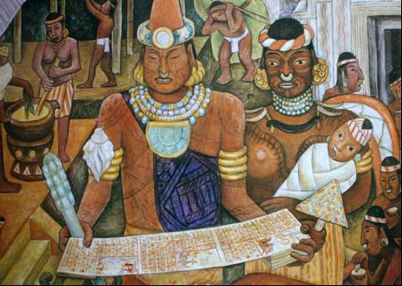
Finally, "the human", was not only inevitably linked to the divine, but at earth, was immersed totally and absolutely in the community. The individual, wheher male or female, was linked to a great obligation and existential responsibility before the Supreme divinity and their community. Serving the community efficiently, was the highest performance that a human being could socially have in life. A human being couldnot be conceived without these two great responsibilities.

This way human beings were metaphorically called - In ixtli, in yóllotl-, “the face, the heart”, giving it a moral and ethical dimension. In ancient Anahuac, men were not born "finished", on the contrary, was perfectible, imbued with a formative process, in which family, school and society intervened. The person through life, especially in the first part, gradually formed "an own face" and a "true heart", education foundation, from where the concept ixtlamachilitzli originates, "action of giving wisdom to the faces and tlacahuapahualiztli," art of raising and educating human beings". Education was considered the highest art, and the Toltec, the Supreme artists.

9. - Telpochcalli and Tezcatlipoca.

The second part of the educational process took place at the first institution provided by the system. The Telpochcalli or "House of youth" was a boarding school where boys entered at about seven years. There were telpochcallis for men and women, which were called Ichpochcalli, schools attended by girls and young women. There they received an education similar to the Telpochcalli, although with relevant female education.

Parents took them to school, prior ceremony made in the parental home, with the participation of family and friends, but in which grandparents and godparents occupied a very important place.

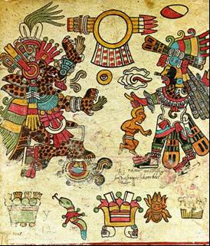
This "farewell from the family" was very emotional and full of speeches, some of which have been collected in the Huehuetlahtolli, given that they were learned and used from one generation to another. This way the boy or girls were motivated, to assume the start of their formal education with joy and responsibility. In the same way parents gave their children to the telpochcalli or the Ichpochcalli in a ceremony, where speeches were eloquent, in the sense of education values:

"Here you are my daughter, my collar and fine feather, my creature and my making, the red of my blood, my portrait. You have come to life, you were born, our Lord Tloque Nahuaque sent you here, the doer, the creator of people on Earth.
Now you realize things, you see how it is here; there is no joy there is no happiness, but sorrow and unhappiness and tiredness, misery; sorrow and misfortunes in excess. Hard place is earth, place of tears and suffering, where sorrow and bitterness are known; it happens, the icy wind glides, it is said that wind and heat really is calmed, but there is hunger and thirst; just like that things are.
Then hear girl, my child; earth is not a good place, one is not happy, not happy because, it is said that there is only joy with fatigue, with sorrow in the land; so said the elders.
So that we were not always crying, so that the macehuales did not die from sorrow, our Lord gave us laughter the dream, carnal knowledge for reproduction, that intoxicates all life on Earth, so that no one walks crying.
Because even when things are like that, even if so are things on earth, shall one hear and be frighten and live crying? Earth is for living, being chief, lord, noble, eagle, tiger. There are those who only are saying that such are things on earth, who only seek to die. But people act, live, construct, work, seeks a woman, he marries, she marries, they mature.
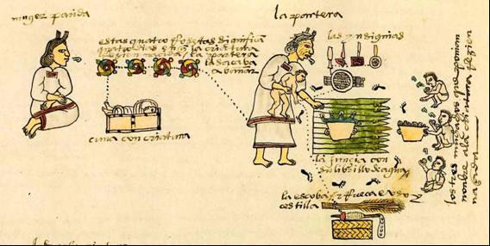
Now then, my girl, hear well, look calmly, here is your mother, your lady, from whose breast and womb you came, you detached, as a dove, as a little plant you sprouted, you threw leaves, you flourished, as if you'd been asleep and woke.
Look, hear, understand, such are the things on earth. Do not just live anyhow, do not just go anywhere. How shall you live, where shall you go? It is said, my girl, little dove, chiquita, that earth is really a difficult place, frightfully difficult…
Live in peace on earth among the people, because you're a young woman; here is the work that you have to do: be devoted night and day, sighing many times for who is Night and Wind because pleading much, calling out loud, open your arms before him in your bedroom, when laying down.
Do not enjoy sleeping; wake up, sit up, get up soon at midnight, go kneeling on elbows on knees, then standup, incline and bow with reverence, invoke, call the Lord, our Lord, who is night and wind, because the pleasure of hearing you at night then will have mercy on you, then will be what you deserve.", Florentine Codex, Sixth Book, Chapter VIII.
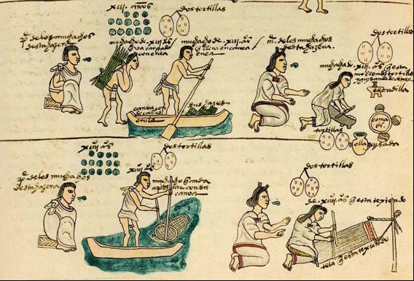

As can be seen in this excerpt, the mother emphasizes that life is not only pleasure and joy. On the contrary, life is faced a challenge of great effort and suffering and hard work, which has some bonuses, "my child in this world, is the place of weeping and afflictions, and discontent, where there is cold and unpleasant air and great heat from the Sun that afflicts us, and is a place of hunger and thirst: this is a great truth and from experience we know." Florentine Codex.
Education was a mean to prepare future generations in the effort and permanent sacrifice. Life, as a self-control and temperance process, internal restraint and external balance. Education was not only based on knowledge. It went further, in values, attitudes, feelings, forming "an own face and a real heart".

The Anahuac civilization was based on education. No other ancient civilization did with such rigor and extended to the entire population. Education was a large state institution, which blended family education, religious, cultural through the formation of values. Parents delivered their children to schools, with security and conviction, of being part of an ancestral process that guaranteed the child development, the development of the community and the state permanence. Fr. Bernardino Sahagún transcribed the children delivery speech to the Telpochcalli:
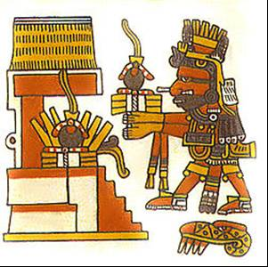
"Here has brought you our Lord, creator of heaven and earth; we let you know that our Lord was served to make us deserve a creature, as a jewel or rich feather, that was born with us; by ventura will raise and live; and he is male, it is not convenient that we teach women duties, having him home.
Therefore we give him to you as your son, and we ask you take care, as you are charged of creating the boys and young men, showing them the customs, and so they serve the gods…"

Children and young people of both genders, were taught not only science, as mathematics, astronomy, biology, or the arts like singing, music and dance; In addition to learning to speak correctly; read and paint their codices, teachers taught some to sow and harvest land, to build, carve, cast, etc. To the girls, planting, cooking, healing, raise, grow plants, weaving and embroidery. Sports and games were practiced for individual and team skills. The Telpochcalli and the Ichpochcalli pretended, first of all, forming "citizens". People capable of living in harmony in society, respectful of the laws and religious norms; productive, self-sustaining and solidary, capable of creating a home and a family, and maintaining the traditions and customs. In addition to honor "He for who one lives" and contribute with his work to the community wellbeing.

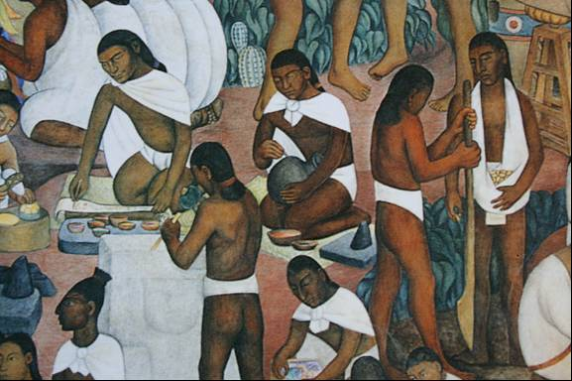
The concept of the efficient and effective education was given by the ability these institutions should have to become self-sufficient. If schools were self-sustainable, pupils were taught in practice and by example, to be self-sufficient.

The telpochcallis formed "citizens", suitable for creating and maintaining a family. Later will go in more detail into this topic, but emphasize the sense of teaching by example and in practical activities, in which not only teachers taught with practice and example, but the system was that older students taught younger children, with different tasks and different responsibilities.

This education level was philosophically dedicated to Tezcatlipoca, in its representation of the "Interior Enemy". Young people had to face the internal enemy that every human being carries inside, i.e., the limitations and defects that drags matter (which contains the "divine spark"), by the gravity force, to the depths of human stupidity.

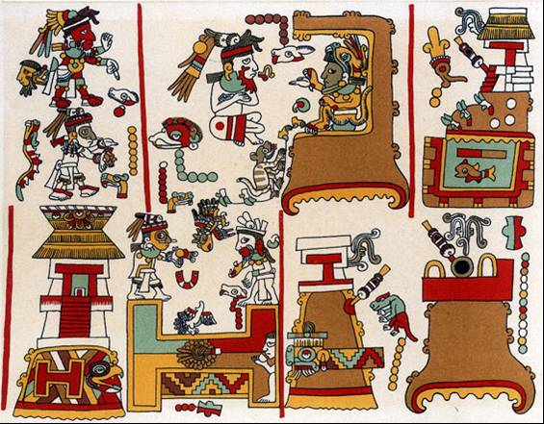
Indeed, the "smoking mirror" concept is the ability to "see ourselves", in an inner transformation process. This is the reason why "the House of youth" was dedicated to Tezcatlipoca. The education on spiritual and community values. The development of self-sufficient and supportive "citizens", ethically solvent and participative, aware of their rights and obligations, their traditions, history and culture, able to form a new family and strengthen their calpulli was the fundamental objective of the classical period telpochcalli.

10. - Cuicacalli. House of song.

The concept of "flower and song" of the Anahuac civilization, has a deep philosophical-educational connotation. Therefore we can assert that as a consequence of this connotation an educational institution existed called "the house of song", understanding that by the "song" metaphor, it refers to wisdom, and flower to beauty, but applied to what is known as "artistic education".

Indeed, for many centuries throughout the Anahuac existed "cultural centers" to which students, women and men, attended in the evening. These institutions were generally located in the center of town and the girls and maidens went in procession, at sun down from their Ichpochcalli, which was located on the side west of town.

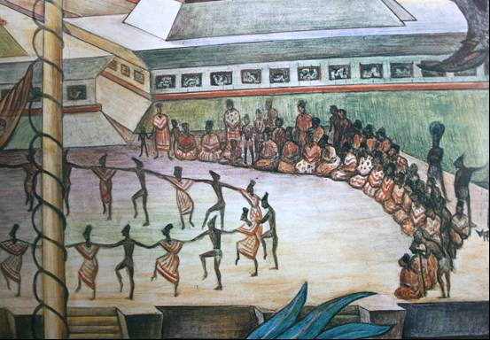
The children and young men went from the telpochcalli, located on the east side. Both went at the same time singing songs and religious hymns, all accompanied by their teachers in a disciplined and solemn procession.

In Nahuatl language, the Anahuac lingua franca, the occidental concept of "art" did not exist. Artistic expressions were intrinsically linked to the conception of the divine Supreme, understood as something abstract, that could not be seen or touched, but that was the means by which the spirit expressed itself. This "language" was understood as "flower and song", that is, the beauty which signifies the perfect balance of the material world.

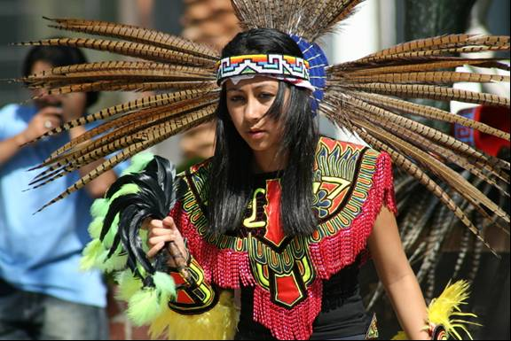
In the House of song, boys and girls socialized performing artistic joint activities, such as: dance, performances we might call "theatrical", singing, musical instruments performance, poetry, oratory, painting, sculpture, engraving, feather art, wood carving and many others, depending on the place and the historical time. We must not lose sight of the fact that this system lasted at least three millennia, in different cultures, in different stages of evolution and various geographical locations. But in general, education had a cultural philosophical matrix which emanated from the Toltecáyotl, that in the classical period found its epicenter in Teotihuacan and the Toltecs were "the venerable masters" of the Anahuac.

11. - Calmécac & Quetzalcoatl.

Education was a very solid Anahuac institution in the classical period. "Basic" education given in the Telpochcalli and Ichpochcalli, was free and compulsory as stated, but as in all societies, individuals have different capacities, levels of commitment and life attitude. The first educational institution received them at the age of seven, to graduate when "they were formed as citizens", between 18 and 20 years old, joining the community, usually through the formation of a family.

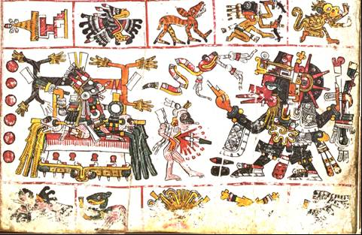

Males who did not marry could go live in communal houses for young people or go to an institution that Dr. Angel María Garibay refers to as " specification institutes", dependent on the calpullis, such as "schools of arts and crafts", where they were taught and perfected as feather art artisans, jewelry, lapidary, medicine, painting, ceramics and various "technical" professions necessary to the community.

Maidens who finished their Ichpochcalli studies, returned to the parental home where lived a life devoted to the family, supporting the mother's side responsibilities. They were very well cared for by all members of the family and led a virtuous life, preparing for marriage and family life. However, there were special schools for those young women who wished to become priestesses, midwives or matchmakers.

So the following Anahuac institution, was reserved for an elite of girls and boys, who were willing to work and discipline, beyond the ordinary. For these young people there was the Calmécac, which literally means "House of measure". As it has been said, for the toltecáyotl or the Toltec wisdom, the equilibrium concept was the base and sustainment, the root of their philosophical thought. As a result, "equilibrium" is achieved through "the measure".

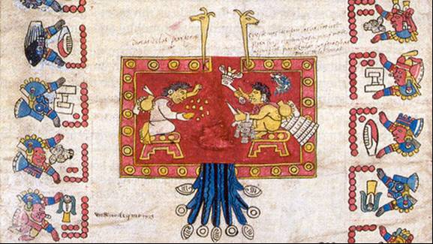

The Calmécac was a higher level educational institution, which formed the leadership of the society. Remember that we are referring to the classical period (200 BCE to 850 CE), in which there were no "Lordships", nor wars and human sacrifices. In the postclassical period (850 to 1521 CE), in particular, the imperialist Aztecs warrior society, who made war and human sacrifice gained momentum from 1440 CE with the Moctezuma Ilhuicamina coming to power. During that period the ancient Toltec education institutions became military schools in the Aztec society; the Telpochcalli formed troops and the Calmécac, trained officers. But this "degradation" was at the end and for a very short time.

In Toltec Calmécac on the other hand, prepared those who would be leaders, administrators, priests and teachers. The instruction was much higher and profound. The sense of historical and social responsibility was exalted in students, the way was higher education. As in all societies, the Anahuac had a philosophical and religious knowledge, reserved for the ruling elite. Religion deepened into theology, mathematics into geometry and calculus, astrology in astronomy, and so on, in the knowledge field. So that the Anahuac educational metaphor of forming "own faces and real hearts", achieved a genuine sense and was the community expression of the supreme aspiration. The supreme ideal of the Anahuac civilization was profoundly and secretively studied in the Calmécac.
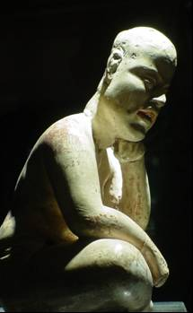
So if the Telpochcalli was closer to a boarding school in our times; The Calmécac was very similar to a monastery, where self-control was promoted, so life was more self-discipline and less institutional demand. Young people studying at the Calmécac, men and women, had a conscious commitment to polish and become the best of them to serve with greater responsibility and effectiveness to their community and the supreme divinity.

The Calmécac was consecrated to Quetzalcoatl, philosophically symbolizing the incarnation "of equilibrium", between the spirit represented by the quetzal, and matter, by the cóatl or snake. But that in the historical-religious aspect was the symbol of wisdom and education. Indeed, Quetzalcoatl taught human beings of the Fifth Sun the prodigy of arts and sciences, so it was the symbol of the desired human perfection.

Unlike the telpochcallis, which existed in each calpulli, and in a town there could be several calpullis, in general, only had one Calmécac in each medium or large dimension town, hence they were regional and were in the center of the city, next to government buildings. The studies degree level required as a result a Faculty of much higher professional level and specific knowledge.

12. - The Tlamachtitlani. The teacher.

Those who were skilled in the art of teaching, that is forming own faces and true hearts, was the teacher, called temachitiani in Nahuatl language. The Toltec teacher concept is:

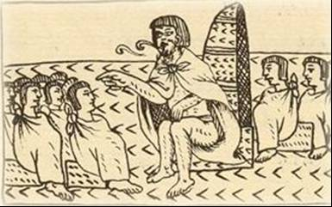
"Heart firm as stone, heart resistant as a tree trunk; wise face owner of a face and a heart, skilled and compassionate.

Teacher of truth,
Does not stop scolding. Makes wise other’s faces,
Makes others take a face, Makes them develop it.

Opens their ears, illuminates them.
Is teacher of guides,
Gives them a way,
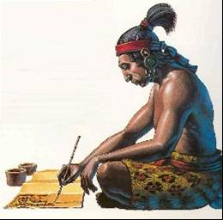
One depends on him.

Places a mirror in front of others,
Makes them careful and wise,
Makes a face appear on them...

Thanks to him, people humanize their love, And receive a strict education.
Makes their hearts strong,
Confronts people,
Help, remedy, attends everyone."
Codex Matritense.

As is appreciated, the temachitiani was more focused on "the value formation", that in the knowledge transmission. Values are related to discipline, responsibility, respect, honesty, spirituality development, solidarity and team work ability. Knowledge transmission occurred in the practice of everyday tasks to make institutions self-sufficient, whether in the milpa, in the pottery workshop or the maintenance and construction of educational buildings. It started from the idea that knowledge without wisdom was harmful to the individual and the community.

The action of giving other’s faces wisdom (Ixtlamachiliztli), is deeply understood with the concept of "humanizing the wanting" (netlacaneco). Indeed, not all human beings desire or wanting can be positive or biophilous for the individual or the community. Humanizing the wanting is the restraint passions, the containment of weaknesses. For the wise Toltec the individual, the community and the world were perfectible, and it is precisely here where education takes its intersectoral and transcendent dimension. Only from this perspective the depth and meaning of Anahuac education can be understood, and the reason why it lasted for three millennia.

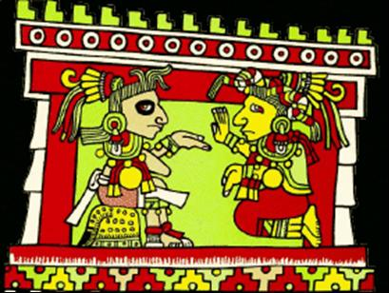

Thus the teacher in his daily tasks, living together in the educational institution with students, taught by example and hence had impeccable behavior. The didactic foundation was to conduct a virtuous life inside and outside the educational compound.

"they began to teach them:
how they shall live,
how they shall obey people,
how to respect them,
how they should deliver to the convenient, the right,
And how to avoid the non-desirable, not right,
Strongly fleeing from perversion and greed.

All there insistently received:
The action which gives wisdom to the other’s faces,
Prudence and wisdom.
Huehuetlahtolli, translated by Angel María Garibay
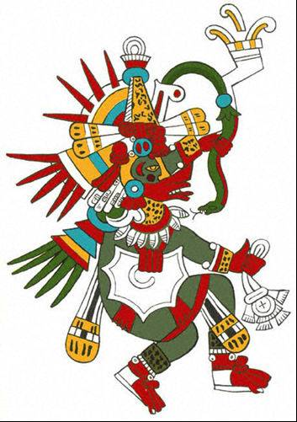
Hence teacher made strong hearts, was a guide, humanized the wanting of students, made them take a face or develop their personality, transmitted wisdom and paced a mirror in front of students so they knew their face, their true heart.

The educational action was not focused on knowledge and the individual. Instead, it relied on values and in the community. Wisdom was the knowledge transmission chain. This is the reason why the Calmécac was consecrated to Quetzalcoatl, as the philosophical symbol of the Anahuac wisdom. Indeed, Quetzalcoatl had created Fifth sun human beings with his sacrifice, had provided them food and had transmitted them wisdom, the art of living, the toltecáyotl.

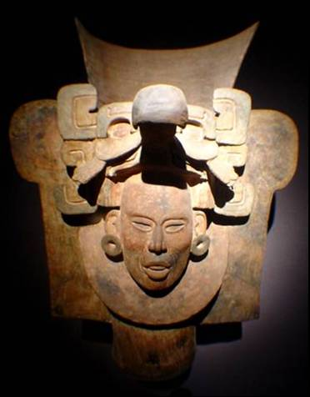
From the philosophical aspect, Quetzalcoatl is the supreme equilibrium point desired by humans. The quetzal symbolizes the most beautiful bird that elevates their plumage to the divine heights of the spirit. The cóatl on the other hand, personifies the most intelligent animal that crawls over the material world. Thus, the Toltec, symbolically represented the balance desired between spirit and matter, through "Quetzal-cóatl". Religious-philosophical figure, promoting the incarnation of the equilibrium balance.

"As Quetzalcoatl teaches that the human greatness lies on a higher order consciousness, his effigy cannot be other than symbol of this truth, and the serpent feathers that represent him should speak of the spirit which allows man -a man whose body, such as the reptile, crawls on the dust- knowing the superhuman creation joy, thus constituting an ode to the sovereign inner freedom. This hypothesis is confirmed, additionally by the Nahuatl symbolism, in which the Serpent depicts matter –its association with terrestrial gods is constant - and the bird, the sky. The Quetzalcoatl is then the sign containing the human being celestial origin revelation." Thought and Religion in Ancient Mexico. Laurette Séjourné. FCE. 1957.

And it did not exist in the Anahuac; better means than education transmitted through the toltecáyotl and the institutions to make this social purpose possible were the Telpochcalli, the Cuicacalli and the Calmécac. But these institutions were administered and managed by teachers. This is the reason why, the teacher from immemorial time is an institution in itself, in a community, especially if it is indigenous or peasant.

13. - The students, boys and girls.

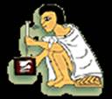
In the Anáhuac the male-female relationship was of equality and complementing. Two examples may give light to understand this complex relationship of social balance.

The supreme divinity, absolute, unique and total, was unnamable and could not be represented, reason why it had no name, was only metaphorically called as "he for who one lives", "Night wind" invisible and impalpable, "he that is here and everywhere at the same time", omnipresent and omnipotent.

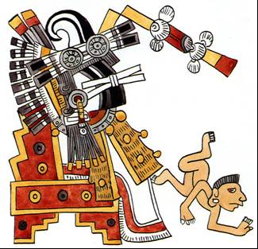
But the same supreme divinity in a "minor" deity was known as Ometeótl, understood as "the divine duality", where "Ometecutli" is from the two the Lord, "Ometecihuatl" of the two the Lady. That is, that the Supreme Divinity in a smaller representation, was composed of a pair of complementing opposites. Male-female, day-night, cold-hot, etc.

Another example is that the Government responsibility rested with two people. The Tlatoani (the one who speak) was who organized and Cihuacoátl (female Serpent) was the administrator. This reflects the complementing dual vision of men and women. That is why, in education, gender held equal importance with different responsibilities and tasks, conceived different but complementary.

The essential for both, was discipline, responsibility, respect among peers and with elders, attention and concentration capabilities, the ability to express themselves properly and behave appropriately, austerity with elegance and frugality with measure, the self-restraint and ego domination, tolerance and humility, conscience of community responsibility, team work, aesthetic beauty and sacrifice.

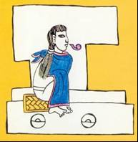
In men, emphasized temperance improvement and willpower development. For women, emphasized virtue development and honesty. For both arts education was essential, "flower and song".

These were values, principles, attitudes and feelings, which were exalted on a daily basis in educational institutions. The means to accomplish it were very strict and severe activities, a myriad of practical occupations to achieve responsibility, discipline, perseverance, self-reliance, and academic, artistic and sporting activities.

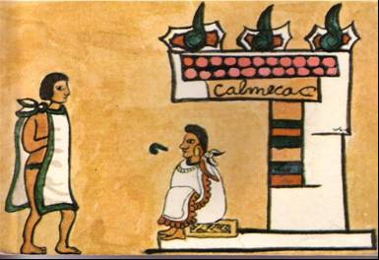
The toltecáyotl asserts that when the student manages to embody the "balance", through the practice of values and principles, will be able to achieve the skills to become self-sufficient and take care of his family and contribute to the well-being of the community. Hence, it is not "knowledge" what transforms the human being, but the values applied with wisdom in everyday life. So they "educated for life".

Through the practice of values, the student may acquire and adequately use knowledge, for their personal benefit, the family and the community. Therefore they insisted that education was the art of "giving wisdom to others faces".

Thus students, men and women, entered the ancient and complex procedures, usages and customs to form "wise faces and strong hearts".
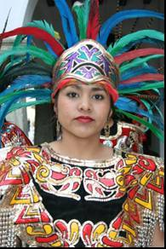
"A face that knows how to make
things happen…
and a straight heart,
a heart respectful God.

A heart strong as stone,
resistant as the trunk of a tree;
a wise face.
Owning a face and a heart."
Codex Matritense.

As the knowledge transmission in the Anahuac civilization was oral in nature, the rhetoric study was of the utmost importance. The use of the fineness of language (and good manners), made the student or "momachtique", able to learn the stories that were remembered on the codices. Indeed, the Codex was not "read", but it was a mnemonic resource, to recall from ideograms, what had previously been learned orally.

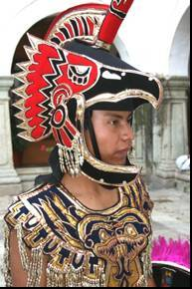
Mathematics, geometry and calculus, were an essential part of their formal education. We must remember that ancient Mexicans were the first civilization that knew and used the mathematical zero. Basic and complex mathematical operations enabled the development of engineering, architecture, astronomy, and astrology. Mathematical calculations to decipher celestial mechanics made it possible for the Anahuac civilization to have the most accurate calendar in antiquity. The use of the nepohualtzintzin or vigesimal abacus, is barely known at the present time, but its use was taught in the Anahuac schools.

The religious aspect, not only was teaching ruling axis, but of all activities, individual, family, community and state, in the Anahuac. Everything was closely related to sacred and divine sense of the world and life. The anahuaca student was born and educated in a religious and spiritual world. But the indigenous religion and spirituality, have very little to do with the occidental Judeo-Christian conception. Bad things were made by the Conqueror and the missionary in judging what they never knew. Unfortunately these colonial judgments are still in force, on the peoples and cultures of yesterday and today. But suffice to say that they were not idolaters, nor fanatical, especially in the classical period (200 BCE - 850 CE).

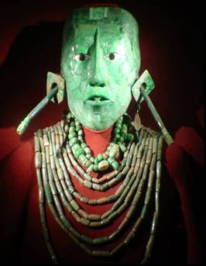
Miguel León Portilla quotes from the Florentine Codex, the profile of the "totec tlamacazqui", priest of our Lord, who directed the "tlacahuapahuliztli" (the Nahuatl art of raising and educating men) and gives us a good example of the religious sense in education:

"Even if he was poor or miserable,
even if his father and his mother were
the poorest of the poor (...)
his lineage was not seen,
only attended his style of life (...)
the purity of his heart,
his good and human heart (...)
his strong heart (...)
it was said that he had God in his heart,
he was wise in the things of God (...)"
Rostro y Corazón del Anáhuac. A.N.L. MÉX. 2001

In general, the students were subjected to intense work ranging from physical to intellectual. The carelessness and laziness were totally prohibited and were severely punished. Same as irresponsibility, theft, but particularly drunkenness, that was punished with the death penalty, regardless of their social origin.

Tasks were given according to age and students themselves instructed younger ones, so they encouraged the "younger brothers" responsibility and teamwork. These tasks ranged from maintaining cleanliness, passing through foodstuffs production and processing and consumables required for subsistence, up to the cult of the supreme divinity, and build and repair school buildings.

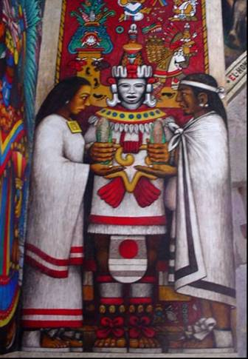
The Toltec sense of educational practice was based on values, which should work on a daily basis with the students, through physical, mental and artistic activities to develop habits, and that these, over time, formed the character or as referred by Nahuatl symbolism: form the student "own face and true heart".

This face, like a solid stone, and this heart, strong as a trunk, will eventually define the fate of their lives.

Guillermo Marín
www.toltecayotl.org
gmarin@toltecayotl.org

Bibliography

RUBÉN BONIFAZ NUÑO
1992 Olmecas: esencia y fundación.
El Colegio Nacional. México.

FRANCISCO JAVIER CLAVIJERO
1964 Historia Antigua de México.
Editorial Porrúa. México

CÓDICE FLORENTINO
1995 Libro Sexto.
UNAM. México.

FERNANDO DÍAZ INFANTE
1988 La educación de los aztecas.
Panorama Editorial. México.

MAX SHEIN
1986 El niño precolombino.
Editorial Villicaña. México.

MIGUEL LEÓN PORTILLA
1979 La Filosofía Náhuatl.
UNAM. México.

1980 Toltecáyotl, aspectos de la cultura náhuatl.
F.C.E. México.

1996 El Destino de la Palabra.
F.C.E. México.

2001 Rostro y Corazón del Anáhuac.
Asociación Nacional del Libro A.C. México.

1991 Huehuehtlahtolli testimonio de la palabra antigua
SEP-FCE México

ALFREDO LÓPEZ AUSTIN
1985 La educación de los antiguos nahuas 1.
SEP-Ediciones El Caballito. México.

1985 La educación de los antiguos nahuas 2.
SEP-Ediciones El Caballito. México.

GUILLERMO MARÍN
1997 Historia Verdadera del México Profundo.
Editorial Tlatocan. México.

RAMON MENA Y JUAN JENKINS
1981 Educación de los antiguos mexicanos.
Editorial Innovación. México.

BERNARDINO DE SAHAGÚN
1979 Historia General de las cosas de Nueva España.
Editorial Porrúa. México.

LAURETTE SÉJOURNÉ
1957 Pensamiento y Religión en el México antiguo.
F.C.E. México.

The Danza de los Voladores (Dance of the Flyers) is a ceremony/ritual which has its roots in the pre-Hispanic period. It is believed to have originated with the Nahua, Huastec and Otomi peoples in central Mexico, and then spread throughout most of Mesoamerica.
A Trompo or Whipping Top is a toy popular in Latin America much like a top. Its name can vary between countries. In Spain it is known as "peonza" or "trompo". Trompos have a pear-shaped body and are usually made of wood, although new resins and strong plastic materials have also been used.
Patolli (the Nahuatl name) or patole (the Spanish form) is one of the oldest games in America. It was very much a game of commoners and nobles alike and it was reported by the conquistadors that Montezuma often enjoyed watching his nobles play the game at court.
Jacks (sometimes called jackstones, jackrocks, fivestones, onesies, knucklebones, or snobs) is a playground game for children.
A kite

