TEOTLAMATLIZTLI,
THE SACRED TIME
…the return of Quetzalcoatl
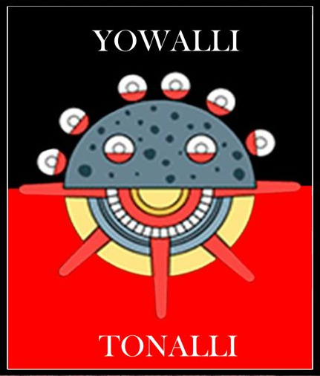

Guillermo Marin
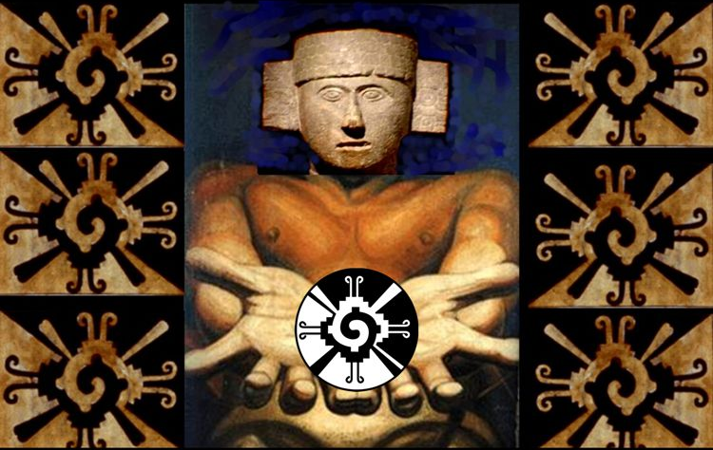

OVERVIEW

The ancient inhabitants of the continent formed a single civilization part of those known as Mother Civilizations. Their energy, time and intelligence were coordinately focused for tens of centuries, to investigate the celestial vault and the energy possibilities. This led them to perfectly understand the perfection of celestial mechanics of the solar system and to visualize the Galaxy, by which they managed an amazing use of mathematics and the use of zero as well as inventing the first calculator called nepohualtzintzin. On the other hand, their research in the energy field led them to discover that there are very small particles of light, very close to what quantum physics today called "string theory". But what is most striking is that they discovered they could manipulate them through an unknown force, although usable, to handle its organization. These fields of knowledge, the celestial mechanics and energy, formed the Foundation of their civilization. And based on this knowledge of the Galactic cycles of Earth and the human energy capacity and the planet we are ending a cycle of five parts and entering the first of another new cycle of five parts.

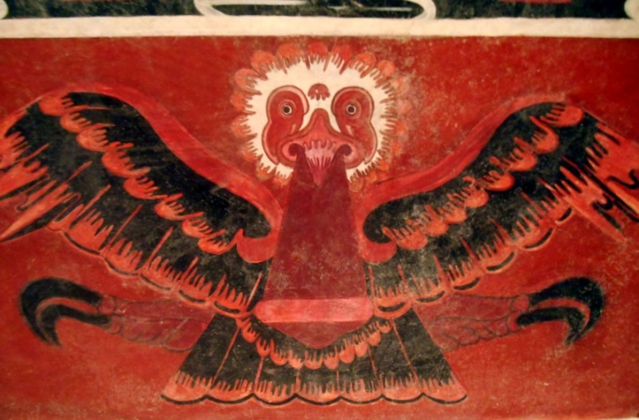
The history and philosophy of the peoples and cultures of the continent, now called America, has been maliciously misrepresented, from the beginning of the invasion, which was based on the premise that on this continent there were no humans, only animals at the service of the "discoverers". Subsequently, when the Salamanca Debate demonstrated that the original inhabitants had a soul, then became humans, but primitive and without knowledge, whom the Spanish had to "Save" for the glory and the benefit of the Vatican and the Spanish Crown. During the three centuries of colony, they tried to eradicate any vestige of the ancient culture. In the last two centuries, the Creoles in power have maintained, in essence, the same attitude, that of the Conqueror to exploit and prey, or that of the missionary break the ancient culture and integrate them into the dominant culture; but in general, cultures of the Anahuac and the Tawantinsuyu, have been excluded from the "Latin American" reality, a Creole project that went from being "Latin America depending on Spain during the colonial period to Latin America, depending on the United States, in the neocolonial period. But both terms exclude the possibility of having the originality and antiquity of a mother civilization, like China or India.

Although denied and not taken into consideration the history and ancestral wisdom, does not mean it is not there. In the case of the Anahuac cultures they hid in an extraordinary clandestine exercise, waiting for the right time and conditions to sprout, because the root has always been alive. Being so ancient as it is has a historical memory, a philosophy and an existential practice of cultural resistance, truly amazing. Despite the Western destruction of ancient knowledge it is known that our ancestors remembered that there had been four earlier "Humanities" or "Suns". In each Sun, humanity improved, developing knowledge to improve material living standards and levels of quality of life in the spiritual aspect, these were contributed to the next cycle or Sun. Every Sun, an upward spiral was destroyed by a disaster involving the loss of a large part of humanity, but without completely extinguishing, so that with better knowledge and enhanced human beings, start another new cycle or Sun.

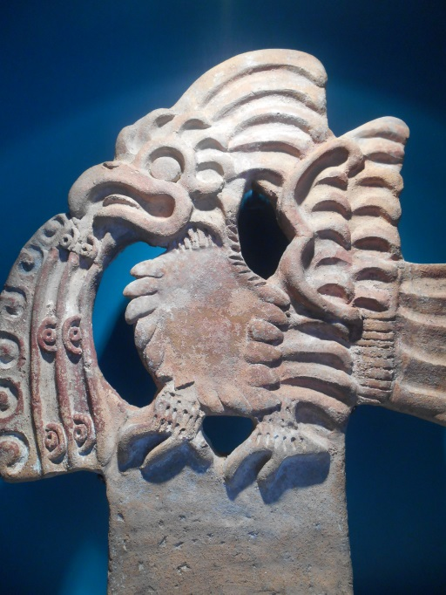
CELESTIAL MECHANICS

The ancient grandparents were great observers of the celestial vault, for several millennia made a rigorous observation, permanent, systematic, measured and reasoned, and in the movement of the stars discovered the perfect measure of time. Our Grandparents who initiated this centuries-old work are known as Olmec, e.g. the people who measured movement. Hence they are the initiators of calendars, beginning with the 260 days lunar. Thus they knew "the movement measure" and discovered that the earth revolves around the Sun in 365.2520 days, that the cycle of Venus was of 584 days, of which disappears during eight days, during 236 appears as the morning star, disappears for 90 days and again appears 250 days as the evening star, that the cycle of the Pleiades was 52 years, and that Earth belonged to the solar system and that it was in a Galaxy, now known as the milky way, and that earth revolved around the center of the Galaxy in 25625 years.

The ancient grandparents divided this enormous cycle in five cycles, each of 5125 years. Each cycle was called a Sun. December 21, 2012 was the end of the last cycle of the five Suns, which began August 11, 3114 B.C. So, so now we are in the new "cycle of five cycles or long count", in the first Sun of the new cycle. Like every calendar, when the last date finishes, restarts a new cycle infinitely. For example: After the hour 24 follows the first hour of the new day, after day 365, starts the first day of the new year, after winter comes spring again. In the case of this new "cycle of cycles", like seasons, they do not finish exactly in the marked day. I.e. climate changes are delayed or advanced and it is a process, it is not a mechanical or immediate change. Hence, although we are now counting the first cycle, the previous has not yet "finished". This process cannot last over a hundred years and within an account of 25625, hundred years or less is a "non-significant adjustment".

At the end of a "cycle of cycles", everything is regenerated, as nature does on the planet with the seasons. In the same way, when completing a cycle around the center of the solar system, everything will be renewed repeating this cycle infinitely. The new Sun is the beginning of a new cycle around the center of the Galaxy, involves an almost total renovation to begin again in and infinite manner.
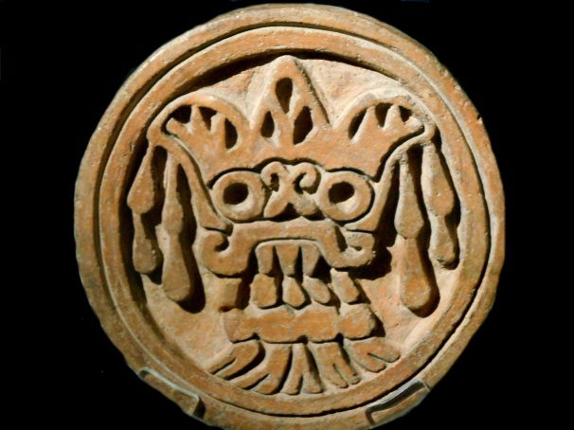
THE conception
of energy

On another concept, the ancient grandparents discovered that all that exists is energy. The concept of "matter" is an abstraction of energy, just like "time" is an abstraction of measured "movement". Differently put, "matter is concentrated energy." The source of energy is inconceivable, as it is beyond human comprehension. This immeasurable energy is unthinkable, invisible, un-nameable, and impalpable. It could only be perceived in its multiple manifestations. The ancient grandparents metaphorically called it in nahuatl Tloque Nahuaque, and symbolically associated it to the Sun and represented it with an eagle, but in truth, it was neither, nor has a name.

From the cosmos observation they learned that energy has a language, and it is mathematics. That everything in the cosmos was perfectly synchronized, had a measure and precise movement. They discovered that energy is a "vibrational frequency" and that everything is interconnected, and all are part of a cosmic balance. In the Mayan language WUINCLIL means "being vibratory of energy".

But what is most striking of their discoveries is that "energy has being consciousness". That the entire universe is a series of energetic charges that are grouped or work as toroid's, just like a planet, a human being or a tree, and that this model multiplied by way of fractals, infinitely in the macrocosm and microcosm. That energy is composed of tiny energy charges with being consciousness. That amazing quantities of these, form what Western science knows as neutrons or protons. But their greatest achievement was discovering that the human being can achieve, through a very complex knowledge, arduous and disciplined process, a conscious domain of their energy. This is, the immeasurable quantity of luminous fibers that have "the will or agreement" to form the individual. A unique achievement and for very few human beings. This is the greatest achievement of civilization.

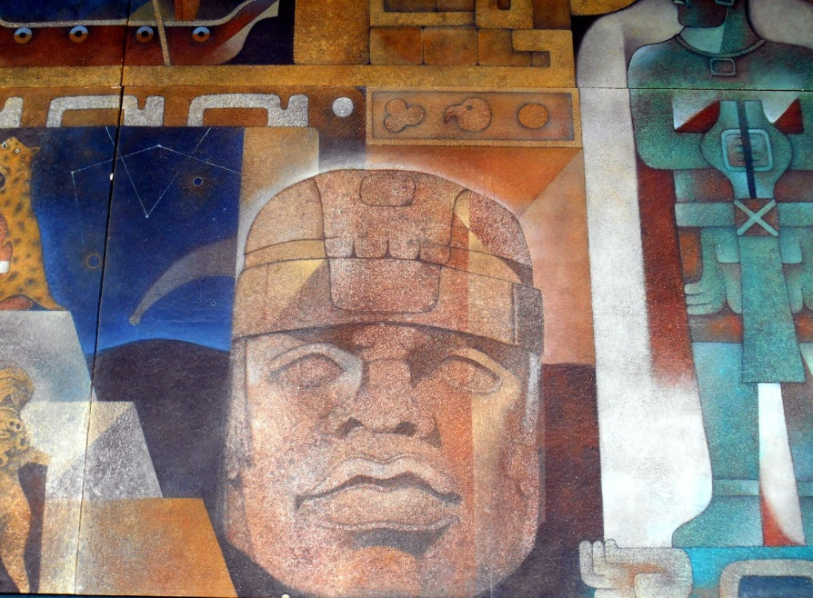
From the energy conception as the only reality that makes up the universe and is in harmony and balance, both in the macrocosm and the microcosm, they interpreted "their world and life", both in the Tlaltipac, as in the thirteen levels, as in the nine lower levels. Their conception of this world and this reality was "cosmic", this explains why most of their energy, time and effort, was devoted to build astronomical observatories known as Tollan (archaeological sites) and in them, in addition to the observation of celestial mechanics, were engaged in exploring the energy mysteries and possibilities through consciousness.

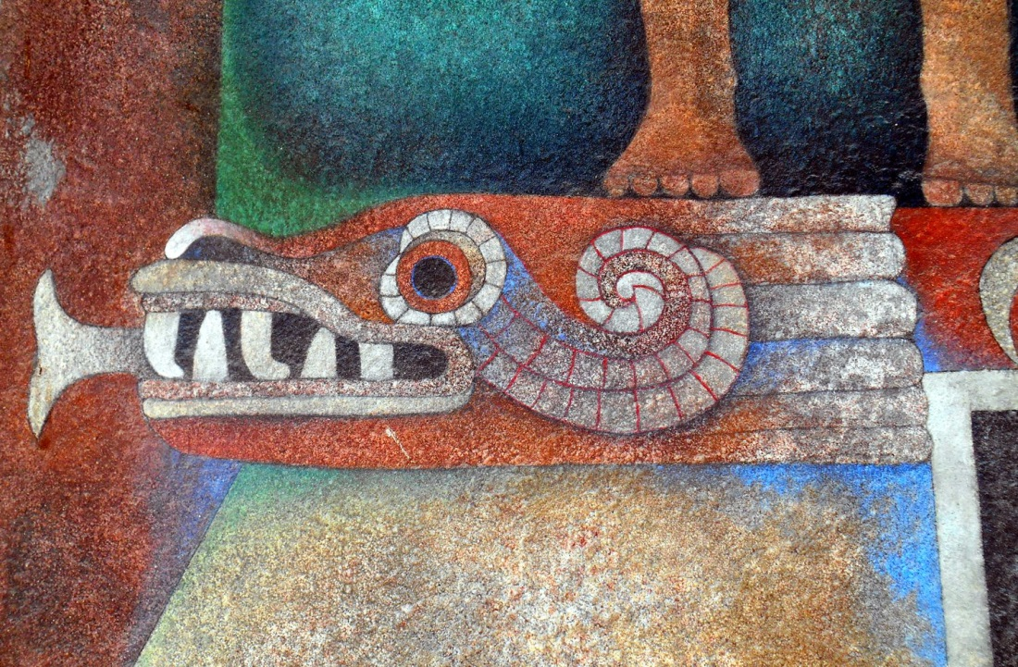
CULTURAL AND EPISTEMIC HERITAGE

These are the two large inheritances or legacies of the ancient grandparents to us, their children's children. In the "material" world, hundreds of Tollanes were built across the continent over many centuries, these operated interconnected with each other, sharing information to measure, reasoning, and documenting the movement of the stars. In the world of energy, spirituality, conceived as the ability to consciously produce a "vibration very close to the frequency of the generating vibration". That is, the ability to harmonize with generating vibration, being able to manage at will the energy that constitutes the toroid called human body.

The discovery that life is a set of fields or energetic frequencies, and above all, that the human being can consciously interact with the energy that forms it. And that the world or universe that surrounds him, in addition to being energy, is governed by an amazing and perfect harmony. The language of such harmony is mathematics. That harmony and balance that rigorous and systematically observed in the sky over the centuries, was the same way in the everyday world in which they lived. This knowledge was the base, the essence, the structure of their civilizing project.
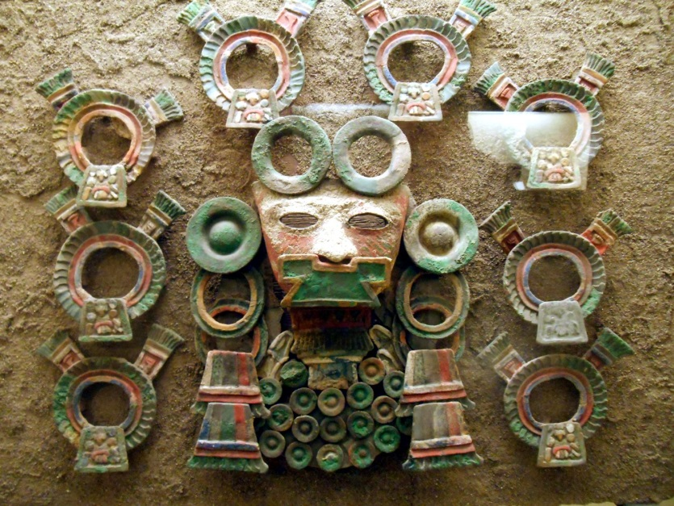
From a decolonized perspective, it can be understood why the continental civilization known as Ixachillan or Abya-Yala, built the most pyramids in the ancient history of mankind. These were never cities, forts or palaces. On the contrary, these were research centers, observation and study of celestial mechanics and the unsuspected possibilities surrounding the conscious management of energy. Hundreds of these spaces were built in the continent. At least during more than a thousand years, known as the classical period.

The spirituality of the various ways of life of all peoples and cultures of the continent, their way of life, the communality, solidarity and reciprocity, love and respect for life in all its forms, austerity and permanent thrift and their rejection to predation and the hoarding, their forms of community organization that today are known as "participating democracy" are the "cultural and community" manifestations of the wisdom known as Toltecayotl.

In the case of the Cen Anahuac, in their lingua franca was nahuatl, we can find, as noted by Dr. Carlos Lenkersdorf, a "cosmic-language"; let us see some of the concepts that help understanding their vision of the world. For example the "teol" concept, meaning divinity or sacredness: Teomatliztli understood as "sacred wisdom"; Teotlacualli as spiritual or divine meal; Teotlamatinime sage of divine things; Teotlanextli light or divine clarity; Neltiliztli understood as "truth".

On the other hand the concept "tona", understood as "energy" is found in very important words such as: Tonatihu "the Sun", Tonacatecutli "Lord of sustenance"; Tonalamatl 260 day calendar and alderman of destinies; Tonantzin our "dear mother" Earth; Atonaui fever; Atonauki Sunny; Cipactonal male creative principle; Tonacatol food; etc.
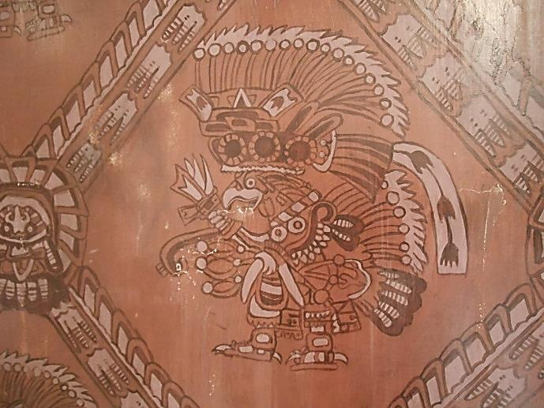

OKACHIUALI

Finally, will note that "TEOTLAMATLIZTLI, the sacred time" is for our mother civilization a way of thinking and feeling time very differently. It is sacred in as far as it is the movement generated by Hunab Ku, and is a vibration, because all what we call matter, is nothing more than energy. Time and energy, apparently different, but form part of the same reality. A cycle that completes itself and is repeated endlessly. This reality led our ancient grandparents to see and understand the world and life in a sacred manner, e.g., as energy.

They discovered that everything is energy. That the universe is made up of energetic particles smaller than neutrons and protons which are in permanent vibration. That these particles are arranged as toroids. That there is a "universe" of toroids replicating as fractals creating the macrocosm and the microcosm that humans can perceive.

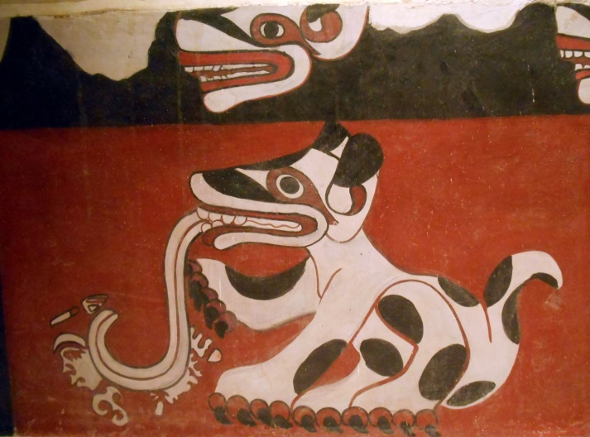
That we live in a solar system and that it is within a Galaxy. That there is a mathematical order in the movement of these large toroids called planets and stars. That that "mathematical order" exists also in tlaltipac or "human world". And that both the macrocosm as the microcosm, vibrate at the same frequency range.

That the planet is part of a mechanism that moves through cycles and at the end of "the long count", we are in the transition from the end of the Fifth Sun, and at the start of the first Sun, in a new cycle of five Suns. That the symbol of wisdom, education, and equilibrium is represented in the Toltecáyotl by the Feathered Serpent, known as "Quetzalcóatl", where the quetzal is associated to the spirit and the coatl to matter. That "the return of Quetzalcoatl" is the resurgence of the balance, harmonious living and human wisdom to start again, what has been initiated and completed many times in sacred time.

Bibliography
__________
- Psychotronics of the Maya, Domingo Martinez Paredes. Mexico. 1981
- Learning to listen. Carlos Lenkersdorf. Plaza y Valdés. Mexico. 2008
- True History of the Profound Mexico. Guillermo Marin. Mexico. 2010.

Cen Anahuac.- Those who completely live together between waters. Notion of territory.
Tawantinsuyo.- Cultures from the south of the continent or Andes cultures.
Olmec, derives from the náhuatl words Ollin=Movement and Mecatl=Measure.
Or Seven Sisters (Messier 45 or M45). The time it takes earth to make a full rotation around the Pleiades is 52 years.
Date encountered on Stelae 2 in Chiapa de Corzo, Chiapas, México.
In Nahuatl language.- Tloque Nahuaque, ‘he who is near, at the side and around things’, from ‘tloc, near, at the side; nahuac, near, around; "Lord of the near and far ".
Maya Psychotronics, Domingo Martínez Paredes. page. 21. 1981.
In náhuatl.- tlaltípac, 'over the land' 'tlalli, earth; ca, place; icpac, over". Terrestrial Plane.
Tollan is a nahuatl toponymal which means place where the tulle abound. But philosophically it is associated to the sites where people of knowledge investigated and studied the Toltecáyotl.
From the nahuatl language, Ixachilan literally translated as "immensity" (Carmen López Nieva).
From the nahuatl language, the lingua franca of the Anahuac, the concept of Toltecáyotl comprises the sum of the best and highest knowledge and institutions of the toltecs, the people of knowledge.
In his book Hunab Kú: synthesis of the philosophical Maya thought, Domingo Martinez Paredes. He suggested that it was represented by the symbol of a square within a circle, or a circle within a square, the circle representing the notion of motion and the square the idea of measure. Hunab Kú as the Tloque Nahuaque nahuatl symbol.

