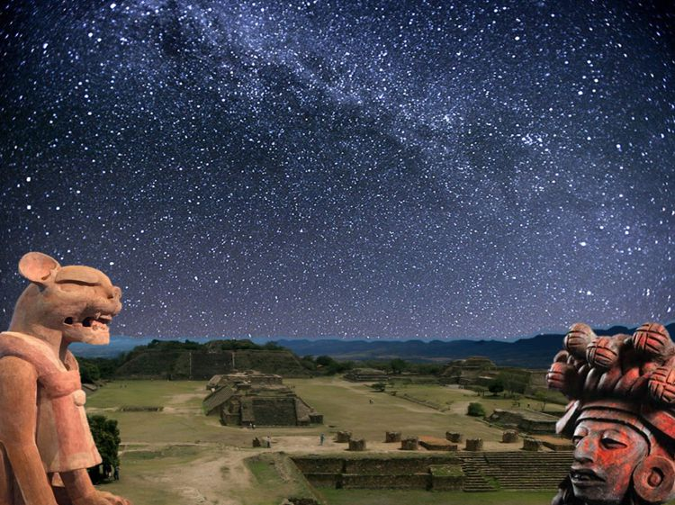
ANCESTRAL WISDOM VS MODERN IRRATIONALITY
Guillermo Marin.

M
ankind ancient wisdom has produced civilization projects in various parts of the planet over ten thousand years, that have created a "pluriverse" of material well-being and spiritual harmony between peoples and cultures. China and India are two contemporary civilizations such as ours, where their intelligence and sensitivity have given many accomplishments to humanity including tangible and intangible benefits.
Modernity only arose in 1492 with the invasion, looting, genocide and knowledge destruction in the continent "Abya-yala/Anáhuac" (South America and North America) by Europeans, setting the bases of the "modern world" through war and trade, generating capitalism and Eurocentrism.
Modernity is a philosophy of death, because in just five centuries have caused the extinction of thousands of vegetable and animal species, the destruction of the planetary ecosystem, the genocide of entire villages, the destruction of global knowledge to impose "a unique and universal thinking for everyone", the destruction of hundreds of cultures, religions and ancestral beliefs, to the point of endangering the existence of human life values.
The modern world bases its death philosophy, in the irrational creation of wealth and its unfair distribution, appropriated and treasured by one percent of the human beings.
This global injustice is achieved through the exploitation of enslaved labor of peoples and predation and pollution of nature.
The method is preying on nature for raw materials, with these, exploiting human beings and with technology manufacture goods and ultimately make people purchase these products thus earning exorbitant and unlimited profits.
In order to achieve this modernity requires, in addition to slave labor and natural resources, management of the market, and to sell and buy, requires irrational consumerism so people work and buy things they don't need.
To fulfill this, it is necessary to destroy the values and principles of ancestral wisdom that remain alive in the ancient cultures of peoples.
So that human beings don't realize the tragedy in which they live, it is necessary to fool and stupefy them. Remove all analytical and critical sense of life, together with the sacred and spiritual meaning of life.
Change the moral and ethical values to vilify them in consumerism, individualism, and degradation. The goal is to create "global zombies citizens".
For this purpose, modernity invented the "representative democracy" (of the money owners) and with their great economic power have corrupted politics, kidnapping democracies in the swamp of corruption, therefore have appropriated the Governments of the "free world", that only work to serve the interests of the Federal Reserve (U.S. private Bank) International banking and the big transnational corporations.
Governments are simple tiny administrators and violent oppressors of their peoples who protest this injustice, beginning with the U.S. Government, which delivers its defenseless citizens to the power of the banks, the mega companies, transnational corporations.
The State nation through immoral use of democratic institutions, constitutionally reduce from their citizens, not only their education, food, health, labor, human rights as well as their unions as workers achievements, but take away from peasants and farmers their historical rights over land and water, so that economies "modernize and companies become more productive and profitable".
On the other hand we have ancient wisdom, which in over 9500 years, never reached the degradation and immaterial and material destruction of the planet as modernity achieved in just 500 years.
As example I will take the creation of the Daany Beedxe Tollan (Monte Alban archaeological zone), although we find "impressive construction projects focused on wisdom and spirituality" of equal magnitude in the planet's six civilizations with autonomous origin: Egypt, Mesopotamia, China, India, Anahuac and Tawantinsuyu.
In the case of "The sacred Jaguar mountain" (Daany Beédxe), in which the 17 anahuaca peoples, of what Oaxaca is today, invested 1350 years (500 BC. 850 AD.) in this formidable construction project.
The Zapotec were not the only building people, because in the year 500 BC., there was not a high population density in the Central Valley, so Daany Beédxe was built, as all the community works have been built from those far away times, it was through "tequio", community work for the common good.
All ancient civilizations of the world, - all-, built pyramids, which were not cities, fortresses, palaces or ceremonial centers. These were research and study centers of biophilic -- knowledge (which enhances life).
To achieve this wonder they required necessarily "The Toltec development pyramid", that is, possessing not only a solid "project generating concept" that had a shared objective and without expiration, common to all peoples and all human beings for thirteen consecutive centuries, but in addition having...
An efficient food system which provided human beings with time and energy to work in these kinds of projects, this they basically achieved with the invention of corn and milpa.
Possession of an effective health system that would provide the anahuacas welfare and physical and emotional fullness to resist the permanent constructive effort, that involved, moving extraordinary amounts of stone for many miles, lifting them 1,320 feet to the top, and work with them and assemble them.
An effective education system that would "convey and involve" new and successive generations in a project as large and long-lasting, in which each new generation took with enthusiasm and passion the work of their ancestors over centuries.
A wise organization system that would allow, from the family and the community, organize all the different towns, of what today is Oaxaca, to coordinate, direct, and supervise the work of hundreds of thousands of people through more than 13 centuries, to achieve this they created more than 3,500 years ago, the participatory democracy, where the authorities "rule obeying the people" through the Assembly. Currently in Oaxaca, of the 570 municipalities, 418 continue to be governed with the "uses and ancestral customs", known as "charge system", where political parties do not participate and decisions are made by citizens publicly in the Assembly.
Without these four systems, it would not had been possible to build over more than one Millennium this impressive work, which was dedicated to the study of celestial mechanics, its mathematical perfection and its relationship with human beings in the field of the perception of energy.
Monte Alban is a stunning example of how the peoples, of what is now Oaxaca, could work harmoniously and in coordination with their authorities to keep alive for 1350 years a great "abstract project" directed at what today we call science and spirituality, but integrated into a single objective, common and shared by individuals, families, peoples, cultures and generations.
But in many parts of the country these projects exist, which are called archaeological sites. The National Institute of anthropology and history, has opened to the public 187 archaeological sites, but has a record of thousands of archaeological sites unexplored and not rescued, and many others that its location is currently unknown.
We have the glory of the Cen Anahuac, only in Mexico, because the spread of civilization goes from the current Nicaragua to the North of the U.S., places so impressive and formidable such as:
Teotihuacán, Uxmal, Palenque, Chichen Itzá, Xochicalco, el Tajin, La Quemada, Tula, Cacaxtla, Cholula, Cantona, Chalcatzingo, Tonina, Tzintzuntzan, Calakmul, Teotenango, Chupícuaro, El Cerrito, frogs, Cuicuilco, Guachimontones, Paquimé, Zempuala, Balcon of Montezuma, La Ferreria, among many others of these 187 archaeological sites, which show us that our ancestors were a people of wise builders, who developed a wisdom and a science that sought transcendence of human existence to higher levels for centuries.
This is the example of what we are and can be in essence, when we work harmoniously between people and Government. In the case of Oaxaca, the archaeological zone of Monte Alban must become a symbol of the greatness and power of the Oaxacan people and their wise authorities.
Rather than a "Cultural Humanity Heritage", Monte Alban must become, - before-"Spiritual Heritage of Oaxacans", which reminds us of who we really are, of what we are made of, what we have achieved and what we can achieve for the future, if we are inspired and know our ancestral past in a decolonized fashion.

June 2016
Oaxaca.

The tequio (from the nahuatl tequitl, work or tribute) is an organized form of work for the collective benefit, it requires that members of a community provide materials or labor to make or build a community work, for example a school, a well, a fence, a road, etc.
The biophilia hypothesis suggests that there is an instinctive bond between human beings and other living systems. Edward O. Wilson introduced and popularized the hypothesis in his book, Biophilia (1984).^{[3]} He defines biophilia as "the urge to affiliate with other forms of life".^{[4]}
Wilson, Edward O. (1984). Biophilia. Cambridge: Harvard University Press. ISBN 0-674-07442-4.
Kellert & Wilson 1995, p. 416.

