DECOLONIZATION IS DIGNIFYING
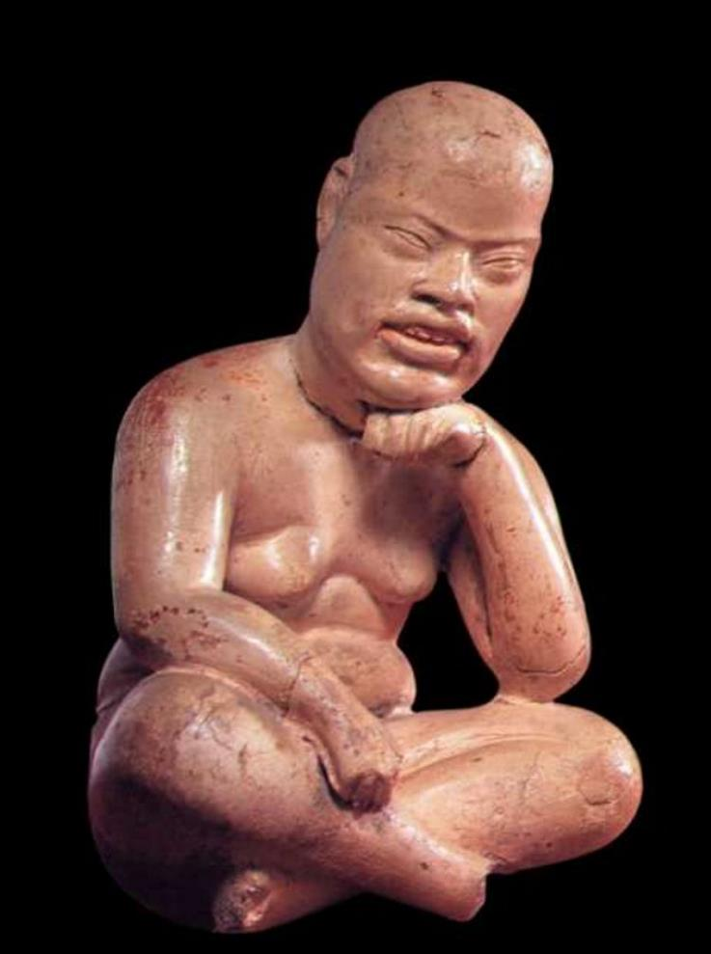
Guillermo Marin

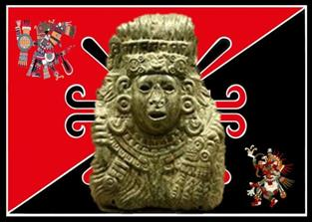
The cornerstone in colonization implementation is the mental aspect. A person, a family, or a people who is mentally dominated, is defenseless and vulnerable to all kinds of manipulation, exclusion and exploitation. The Viceroyalty of new Spain developed its domination over conquered peoples by the eradication of ancestral tongues making people mute and silent; the elimination of the historical memory leaving them amnesic; the destruction of their knowledge leaving them stupid, incapable and powerless; taking away their spaces, not only the best lands but sacred, community and historical spaces; and finally, forbidding their ancestral spirituality leaving them fanatical and idolatrous of an alien religion from which they were excluded.
With the invasion and sacking of Ixachilan (American continent), Europe capitalized itself and initiated modernity, capitalism, eurocentrism and the material and cultural domain of much of the planet. This was accomplished, -among other things-, by the destruction of the ancient knowledge and wisdom of the world and at the same time, the implementation of the "single thought", e.g. Eurocentrism as "universal, one that defines for all", e.g. the European thought "is natural and inherently superior" which is valid in any part of the planet, regardless of historical, social and cultural processes lived in specific places, no matter how far apart they are. Eurocentrism imposes the dogma that knowledge born in Europe is the first, e.g., exact sciences, natural and social have their origin in Europe, which is totally false. Thus, in the five centuries of "Eurocentric modernity", in the colonized countries, economic elites, political and intellectual use categories and think and conceive the world and life as Europeans.
In the approximately ten thousand years that humans live in civilization, there have been six-core generators or mother civilizations, these are: Egypt, Mesopotamia, Anahuac, Tawantinsuyu, China and India, from which branched thousands of different cultures in time and space. Each of them kept hundreds of years of continuous splendor. The western culture does not have an autonomous origin, is a product of cultural appropriation and offal and is the most recent of the planet. However, during the last five centuries has been the dominant culture through economic, military and political power, and also, with a planetary sense of dominance that no other had. The point is that unlike the ancestral civilizations, the western culture has been characterized for being a necrophiliac culture, e.g., a culture of death. Indeed, in the last two hundred years has endangered humanity and the very planet of death by implementing its domination model.
The paradigm of the Western culture is that happiness and fullness of human beings are accomplished through the development of the material world through wealth and consumption. Consumption as essence of human beings and money as the only means to achieve happiness and human realization. This paradigm is opposed to the vision of the world and the lives of other civilizations and ancient cultures of the planet, which are focused on the development and spiritual realization. To impose the Eurocentric ideology it required the destruction or distortion of ancient thinking and spiritual values that are implicit in community knowledge, traditions, festivals, uses and ancient customs of all peoples. The western culture has created a modern form of the "golden calf" cult, and modern societies, such as that of the U.S., and in general, the upper class societies of many colonizing and colonized countries live in an irrational pursuit of the necrophiliac form of finding "happiness", which is leading to excessive drug consumption to mitigate the existential frustration that produces consumerism and that only generates vacuum and frustration.
Before rales of death of the modern world and its necrophiliac ideology in which they live, peoples should seek in ancestral wisdom the answers to dismantle this "cancer" that is affecting the largest part of its population and the very planet, known as "the House of all". This is the reason why we must stop using the categories, concepts, visions and perceptions that modernity, capitalism and Eurocentrism, have created in its predatory action againts life and humanity. We must re-seek, re-think, re-signify life, from the perennial knowledge of each people in a pluriversal concert. It is required to restart from scratch, from the beginning, from the most essential and pristine, from the genuine.
Purify the concept "to be alive and be conscious", of the meaning and objectives of being, of living in family, community and in harmony with all living beings on the planet, the suns and the stars. Find again the vibration frequency to harmonize our energy and consciousness with "everything". Re-signify the divine and sacred of the world, life, and the immeasurable.
In the case of those of us who live in the Cen Anahuac (Central and North America) the Toltecayotl represents the perennial wisdom that was the product of thousands of years of observation, testing, analysis, systematization, dissemination, and preservation of knowledge of all the peoples and cultures that formed one of the six mother civilizations. The Toltecayotl implies an incommensurable effort through knowledge to offer balance, fullness and existence transcendence to humans. Through the pyramid of Toltec human development, i.e., the integrated, interdependent systems of food, health, education, organization, which provide the material basis to achieve well-being. Fullness was achieved in the field of the divine and sacred, in the full and total "energy consciousness".
For these reasons, we believe that the mental and cultural decolonization is one of the most difficult and urgent tasks that we have to face. As our old grandparents called the inner battle, mental decolonization represents the current "Florid Battle", to achieve consciousness, dignity and intellectual sovereignty. Involves the arduous daily task, systematic and permanent to "see us and feel ourselves" in our daily lives immersed in a colonized medium, Westernized, capitalist, modern, consumerist, racist and Eurocentric. In our acting as "colonizer-colonized", fighting against "The Hernan Cortes and Malinche" who live deep in our hearts, and that at the first opportunity burst out violently to subject, despise and exploit.
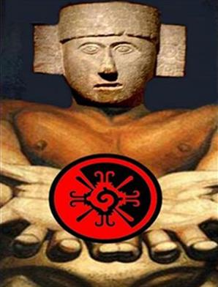
Especially and with energetic rigor the intellectual decolonization must be for those who work to return to the root, to the wisdom, the uses and customs of our ancient grandparents. We cannot and we must not "give us intellectual tolerance". We must be impeccable in our daily lives, in our thinking, the way we speak, write and live with our people. We must banish concepts and categories such as: "pre-Hispanic, Indian, race, indigenous, Mesoamerica, pre-Columbian, pre-Cortes, dialect, confuse civilization with culture, Aztec with Mexica, Shaman by tlamatinime with person of knowledge, etc."
All words have an ideological load, in general, those relating to our ancient grandparents and mother civilization, in the Spanish language, are all full of malice, prejudice and ignorance, which aims at massively and daily make us feel less and submit us intellectually.
Decolonization does not imply rejection and denial of the cultural appropriations we have made throughout five centuries, not only from the cultures of Europe, but also of Africa and Asia. The cultural and racial miscegenation is always beneficial, valuable and productive. We cannot go to the other extreme. Today more than ever, mankind can and must live in a harmonious epistemic pluriverse and cultural, in which every people and culture offer to others what it has, and take from others, what needed to find their fullness and realization.
Decolonization requires us to be vigilant and observant of not falling into the "folklore" of our ancient ways of living and interpreting the world. Folklore in this case, taken as the vision that the dominant culture has on the manifestations of the dominated cultures. Decolonization requires us to go to the root to the essence, to the incorruptible. The form does not matter, but the depth of these roots. Forms may vary over time and space, but the base is "immutable".
It is very dangerous to take the past and the values of our ancient culture, as a fad, a distraction, consumption, a business, a weekend entertainment. The Anahuac mother civilization and all that implies the Toltecayotl, is our most precious heritage, the wisdom with which we can face the degraded modern-eurocentric-capitalist world. It is our only real chance of entering the new cosmic cycle in harmony.
We are at the beginning of the new Sun; the fifth ended December 21, 2012 according to measures of "space-time", when Earth completed its travel around the center of the Galaxy. As the spring beginning, it does not match exactly March 21, sometimes it comes earlier and others later. In the same way, the Fifth Sun, although in time and space already completed astronomically, the "effects" of the new Sun are not felt immediately. On the other hand, experts say that at the rate the planet is contaminated, destroying nature, financial and energy crises, the disappearance of animal and plant species, as well as socio-cultural breakdown that many people on the planet are suffering, the "modern-capitalist-eurocentrist" system and the planet, barely has one hundred years of life, as we now have it. One hundred years, in the count of 25625 years represents a slight variation, as the changing of seasons. As you can see, we no longer have much time left in the extension of the Fifth Sun.
We cannot irresponsible and unconsciously gamble with the future of life. Every person, every family and every people are part of this world. Everyone has a responsibility. One of the features of the civilization of our ancient grandparents was the awareness of the responsibility that each individual had with the preservation of maintaining the "balance" and life on Earth and in the universe. To fulfill this responsibility, our mother civilization inherited us the Toltecáyotl. We have to be very respectful and careful with this heritage. The Toltecáyotl is "divine matter" and the weapon for the "Florid Battle". The Toltecáyotl is "flower and song", our future to start the new Sun. Decolonization is dignifying.
Oaxaca, April 2016.

Dr. Ramón Grosfoguel. Seminario UNAM. Marzo 2016.

